**Information provided in this project report is unique & confidential to its proposed software platform; anyone reading this project proposal agrees not to disclose any of the business information in this proposal without any permission from the CS Group 19.**

# Group and Supervisor details

Proposed Project Supervisor

Name of the supervisor: Dr Shiromi Arunatileka

Email: sda@ucsc.cmb.ac.lk

Date: 08/29/2021

Proposed Project Co-Supervisor

Name of the co-supervisor: Mrs. Ishani Fonseka

Email: cli@ucsc.cmb.ac.lk

Date: 08/29/2021

*There is no specific client for this project and it’s a startup idea.

# Group Number & Members Details

Group Number: 19

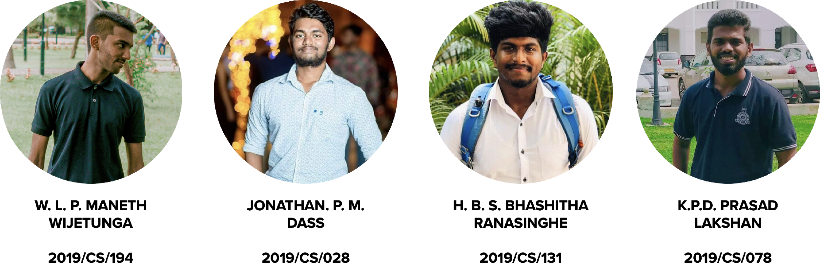

# Confirmation to submit the project proposal

### 

### Confirmation from the Supervisor: Dr Shiromi Arunatileka

### Confirmation from the Co-Supervisor: Mrs. Ishani Fonseka

CONTENTS

Group and Supervisor details i

Group Number & Members Details i

Confirmation to submit the project proposal ii

Confirmation from the Supervisor: Dr Shiromi Arunatileka ii

Confirmation from the Co-Supervisor: Mrs. Ishani Fonseka ii

1. Project Title i
2. Project Goals & Objectives i

3) Problem Definition ii

3.1 Proposed Solution iii

3.2 Business Process iii

3.3 Uniqueness of Our Project iv

4)Scope of the project v

4.1 Main Users v

4.2 In Scope - Main functionalities v

4.3 Out of Scope vi

4.4 Flow of events in the current context vii

4.5 Flow of events with Sportizza viii

1. Technologies x

5.1 Front-end development of the web application x

HTML5, CSS3, and JavaScript (JS). x

5.2 Back-end development of the web application xi

PHP and MySQL. xi

5.3 CASE tools for the system development process. xi

Draw.io, Workbox, git, GitHub, X xi

6)Project feasibility xii

6.1 Technical Feasibility xii

Integrated Development Environment: xii

Tools & Utilities: xii

Hardware: xiii

6.2 Operational Feasibility xiv

6.3 Legal & Ethical Feasibility xv

6.4 Social Feasibility xvi

6.5 Economic Feasibility xviii

6.6 Schedule Feasibility xx

1. Project Constraints and Limitations xviii
2. Requirements of the project xx

8.1 Functional Requirements xx

8.2 Quality Attributes xxvi

8.2.1 Security xxvi

8.2.2 Availability xxvi

8.2.4 Performance xxvii

8.2.5 Testability xxvii

8.2.6 Usability xxviii

8.3 Use Case Diagram 27

1. Design Specifications 29

9.1 Component Diagram 29

9.2 Class Diagram 34

9.3 Entity Relationship Diagram 34

9.4 Sequence Diagrams 34

9.5 Use Case Descriptions 34

1. User Interfaces 94
2. Deliverables of the project 95
3. Declaration 96

# Project Title

This project is carried out by a group of undergraduates from the University of Colombo School of Computing with regard to the 2nd academic year of bachelor’s in computer science. The project is aimed at developing a third-party platform that facilitates sports enthusiasts to search and book the nearest sports arenas and for the sports arenas to attract more customers to their under-utilized facilities. The name of our proposed platform is “Sportizza”.

Sportizza is a platform driven by the desire of building a healthy nation by getting more people involved in using the existing under-utilized sports grounds, playing fields such as football courts, cricket grounds, volleyball courts, gyms, swimming pools, etc. within the island while enhancing the revenue of the sports arenas in the meantime.

# Project Goals & Objectives

The ultimate project goal of carrying out this project is to provide a convenient and efficient mechanism for the potential customers to make bookings for sports arenas while supporting the sports arenas to operate effectively when it comes to booking handling related services and providing effective business insights for the sports arenas to operate competitively within the industry.

Over the long term, as a next step, we also have plans to expand the scope of the platform by adding more partners such as sports equipment merchants, sponsors for sports events, etc. However, due to resource constraints, those aspects won’t be covered under the current project.

Increased concise on living a healthy life with adequate exercises is on an upward trend from the recent years. As Sri Lankans, we also have a tendency in moving towards a more healthy nation. As a part of the long-term vision “Hope of building a healthy nation” we are planning to develop this Sports Arena booking platform Sportizza to get more of the populations to use the existing sports arena resources within the island.

Additionally, we aim to achieve the following objectives in our journey:

* Simple User Interface for the users.
* Make the sports arena booking procedure more convenient for the customers.
* Providing customer feedbacks for the above-mentioned sports arenas to improve their current facilities.
* Providing analytics to the sports arenas to take managerial decisions.
* Helping out the sports arenas to manage their bookings easily with sportizza.

## 3) Problem Definition

Currently, when making a booking to a sports arena, customers have to go through so much hassle by making calls to a significant number of sports arenas and check whether they have that particular time slot available in their sports arena and if not, what are the other time slots available. Perhaps, the customers must make another call to confirm the booking a few days prior.

All the service sector businesses inherit the issue with quick expiration of their service. For the instance, sports arenas might not be able to make any revenue from a time slot of a particular date if the time slot is not booked by any customer, Hence, the opportunity cost gets increased for the sports arenas over the long-run due to under-utilisation of its facilities.

Hence, both the customers as well as the sports arenas face numerous issues in the current context. To be more specific, these are the main issues faced by both the parties:

* No method to search the sports arenas around.
* No method to check the available time slots of a sports arena without giving a call to the sports arena.
* No method available to check the details, facilities available before using the facility.
* Sports arenas are experiencing issues due to sudden booking cancellation by the customers.
* Sports arenas are not receiving any revenue for the bookings which were not utilised but confirmed as bookings by the customers.
* No easy method for the sports arenas to emergent booking cancellations.
* Not having sufficient demand for the sports arena facilities.

## 3.1 Proposed Solution

We aimed at these issues and proposed a software-based solution namely “Sportizza” which would allow the customers to search the available sports arenas for a particular time slot and make the booking then and there without making a single call to sports arenas. Additionally, the sports arena would also receive a guaranteed payment made on their allocated booking slots. Some more added functionalities would also be included such as a rating system for the sports arenas, sharable link generation for the customers so customer could share the booking confirmation with the other collogues via social media, etc. Similar systems are available in other countries like Oman, India, Ireland, UK, etc., but none in Sri Lanka.

## 3.2 Business Process

Our ultimate goal is to make this platform the best solution for the customer to make bookings in a more convenient manner and facilitate the sports arenas to manage their bookings. Maintenance is important for a website to be a competitive and attractive platform over time. Hosting, Storage, SMS module, API keys and other maintenances shall be the direct costs involved for the system. This platform shall gain revenue mainly by charging a 5% royalty fee for every booking transaction happen through our Sportizza Platform and additionally, Sports Arena’s are charged a fee for promoting their sports arena on top of the search results. Furthermore, Sportizza will charge the sports arenas for any advertisements placed on the site and for any sophisticated data analytics reports based on the requirement. This income should be sufficient to cover the costs of maintenance of the platform in the future.

## 3.3 Uniqueness of Our Project

In the current context, there is no such similar platform in Sri Lanka to connect customers with the sports arenas to get their bookings done. With the increased concise on health-concerned lifestyle among Sri Lankan population, demand for the sports arenas is also on an upward trend which means that there is a market vacuum exists in this field and hence, this project has a great opportunity in terms of business expansion.

Additionally, group members of this project themselves are facing this issue in their day-to-day life. That’s also one of the main motivations for our group to select this issue and propose a workable solution as responsible undergraduates from the University of Colombo School of Computing (UCSC).

# 4)Scope of the project

This section provides an overview of what areas shall be specifically covered by Sportizza platform and what areas shall be out of its scope. There are mainly 6 users who shall be using the system.

## 4.1 Main Users (Actors)

1. Admin
2. Visitor
3. Customer
4. Manager
5. Administration Staff
6. Booking Handling Staff

## 4.2 In Scope - Main functionalities

The areas that are specifically handled by the system include:

* Registration and authentication.
* Search for sports arenas.
* Make bookings.
* Add bookings to cart.
* Do card payments for bookings.
* Cancel bookings.
* Provide ratings to sports arenas.
* Sports arena listing in the platform.
* Invoice generation for the customer.
* Adding bookings to Cart and checking out at once.
* Analytics generation for sports arenas.
* Cash payment processing for sports arenas.

## 4.3 Out of Scope

The areas that are not specifically handled by the system include:

* Discounts on booking time slots.
* Booking rescheduling.
* Booking timeslots with coaches.
* Sports equipment merchandising.

## Diagram Description automatically generated4.4 Flow of events in the current context

As mentioned earlier, the current sports arena booking system is a bit inconvenient for the customers as well as the sports arenas. The below elaboration includes how the process happens in the current context as per figure 1, without the Sportizza platform.

Firstly, the customer should call a sports arena and check whether it is available on the customer’s required time slot. If it’s available from the first call, the customer was lucky and he just has to make one more call to the sports arena at a later stage in a normal scenario.

However, in most cases, the customer has to make few more calls to other sports arenas and check the availability if the previous sports arena is not booked.

For the instance, let’s assume that a customer founds out an available sports arena for their required time slot after going through so much hassle. Then the customer has to provide their NIC number, name and mobile number when making the booking. Furthermore, the customer has to again give a call to the sports arena and confirm their bookings 3 days prior.

From the sports arena’s perspective, they would receive the corresponding payment only after the customer using the facility. There are scenarios where the sports arena couldn’t make any revenue as some customers have cancelled their bookings at the last minute and some customers haven’t used the facility for their booked time and ultimately all these events lead to loss of revenue and resources for the sports arena. That’s just a gist of how the current process happens in the practical environment.



*Figure :Current flow*

Figure 1: Current flow

## Diagram Description automatically generated4.5 Flow of events with Sportizza

## With the introduction of the Sportizza Platform, we expect the process to be smoother and more convenient for both the customer and the sports arena.

Firstly, the customer can book a time slot in 2 main methods as per figure 2. The customer has the option to search for a particular sports arena and selects a time slot or the customer can search for a timeslot and select a sports arena. After this stage, the customer is getting the option to select a required time slot to proceed with the booking.

One of the most critical aspects of our system is that anyone with an internet connection and a mobile device or a personal computer could search for the available time slot irrespective of whether they want to make a booking or not. However, only a logged-in customer would be able to proceed with the next stage, which is to make a booking via our platform.

When considering the payment option, Sportizza provides the authority for the sports arena to decide whether they accept cash payments, card payments or both. Only the card payments would be handled by our platform by incorporating the service of a third-party payment gateway.

After a successful payment process, the customer would receive a booking confirmation which could be shared with the customer’s colleagues who would be using the facility with him for that particular time slot. For the sports arenas that accept only cash transactions, Sportizza would send the same booking confirmation message to the customers and the customers could show that booking confirmation to the sports arena’s administration staff and make the payment for that booking. Thus, the risk of the cash payments is totally out of Sportizza responsibility.

Figure 2: New Flow

The above-mentioned Sportizza is also allowing the customers to provide feedback on the sports arena after each booking so that the sports arena could keep on improving their service and provide a high-quality service to the customers from the next time onwards.

# Technologies

## 5.1 Front-end development of the web application

### HTML5, CSS3, and JavaScript (JS).

One of the main reasons for using the above technologies for our project work is that we are not allowed to use other frameworks which can be incorporated in developing software. However, these frontend technologies such as HTML5, CSS3 and JS still supports a wide range of web browsers in mobile devices as well as laptops and personal computers. Since we have both the sports arenas as well as the customers as our users in our platform, we have chosen this software over the other software. Furthermore, JS is used to make the user interface of Sportizza more dynamic.

## 5.2 Back-end development of the web application

### PHP and MySQL.

A few of the most critical reasons for our group to choose these technologies over the other substitutes such as Java programming language is that it’s easy to learn and extremely flexible when it comes to programming. Furthermore, it also provides us with easy integration and compatibility over devices. MySQL is mainly used in this system due to its scalability and higher performance than the other substitutes.

## 5.3 CASE tools for the system development process.

### Draw.io, Creately, GitHub, VS-Code, Google lighthouse

Draw.io & Creately is used to draw the online diagrams and share them among the group members. Since the group members are individually working on their area without having dependencies, version controlling with GitHub is more convenient for the group to carry out their project. VS code is used as the IDE to write our development scripts. Google light house is and the other developer tools are used for reviewing and adapting the best practices to the platform.

# 6)Project feasibility

## 6.1 Technical Feasibility

In order to complete the project on time and meet the agreed deliverables, we have planned to use the following technologies such as HTML, CSS, PHP and JavaScript as our implementation techniques. All IDEs used for development are free and open source.

Laptops and desktops required to carry out the development with the relevant hardware requirements are owned by the group members.

### Integrated Development Environment:

* Visual Studio Code

### Tools & Utilities:

* XAMPP & MAMP
* Version management- GitHub
* Draw.io & Creately – UMLs & other diagrams
* JIRA - To manage tasks among group members
* Adobe Illustrator- logo making
* Microsoft Office 365 (Student edition provided free for university email)
* Grammarly -Free edition to eliminate grammar mistakes
* Google Lighthouse – To audit the System Performance

### Hardware:

* Personal laptops
* Routers

### Domain & Hosting:

* Amazon Web Services’ Elastic beanstalk is used for the deployment of Sportizza.
* Amazon Web Services’ Relational Database Service is used for the database management.
* Cloudflare’s domain is used for Sportizza.

Below is a Screenshot of our GitHub Repository of the project

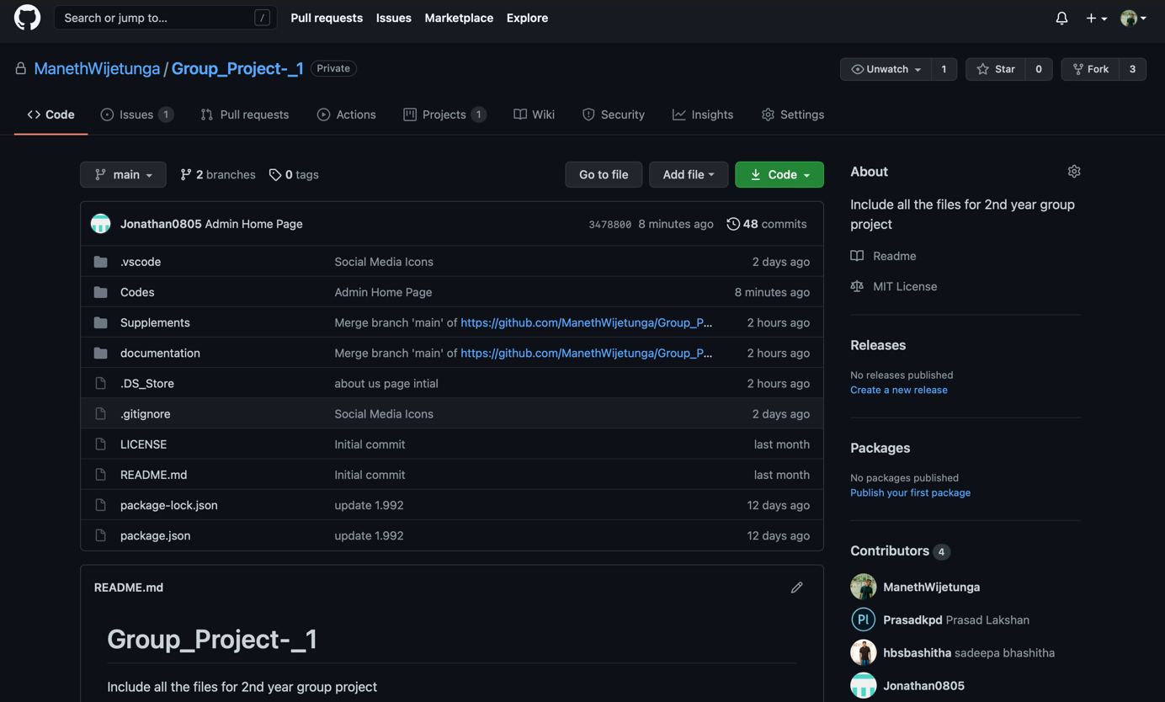

Figure 3: GitHub Repository

All the above-mentioned resources are easily usable within our knowledge limits.

***Hence the project is technically feasible.***

## 6.2 Operational Feasibility

Firstly, for the proposed platform to be operationally feasible, all the identified functional requirements should be included in the software. Most importantly, the system should increase the convenience of the customers as well as the sports arena staff for this system to be operationally feasible.

In order to use the system, there are certain aspects that have to be fulfilled by the users. They are as follows:

* Users (Manager, Administration Staff from sports arena and the customers) should have a medium knowledge in IT and English.
* A device with internet connection is required to access the platform.
* If the sports arena’s manager and administration staff could have personal computers or laptops, it would be easier for them to carry out their operations via the proposed platform.

Affordability Vise, the ground sports arena is charged only 5% of each booking from the platform and if any other extra statistical reports are requested, they would get charged an additional fee depending upon the content requested. Customers won’t bear any fee throughout the process.

Additionally, one of the main aspects considered when developing this platform is to have a user-friendly interface including convenient navigation, performance, and mobile compatibility so that users can easily access the application using their smartphones.

***By considering all these aspects, it's clear that our proposed system is operationally feasible.***

## 6.3 Legal & Ethical Feasibility

The proposed system shall contain large databases of sensitive user data such as the name, mobile number and the account password. We have to protect our databases from unauthorized intruders and also guarantee the user’s privacy and confidentiality. As a remedy, we are planning to add all our privacy policies to our user agreement. Hence the customers can read the agreement document before entering their data into our databases.

A hierarchically based login mechanism is to be used in the system so that only the relevant authorized users can view the data available to them. As an example, the booking handling staff would find only a limited number of features than the administration staff of the sports arena.

For online payments, the support of a third-party payment gateway is being used. Since it’s a trusted software that has already processed over Rs 1 billion worth of transactions, it's safe to assume that all the transactions could be done with trusted, standardized payment providers over a secured connection.

***Hence, our system is legally and ethically feasible.***

## 6.4 Social Feasibility

We have performed a survey to identify the impact and the intensity of this issue for society by using a google response form. As of now, we have received a total of 155 responses. Below are a few of the analytics which we derived from the responses we received:

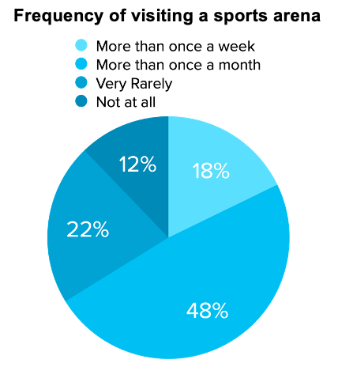

The pie chart in figure 4 depicts the frequency of a regular person visiting a sports arena. As per the survey, 18% of the average population visits a sports arena more than once a week and 48% visits a sports arena more than once a month. This means that more than 66% of the population visits a sports arena at least every month. This highlights the frequency of people visiting a sports arena. Hence, it is clear that our proposed solution would be effective for the society.

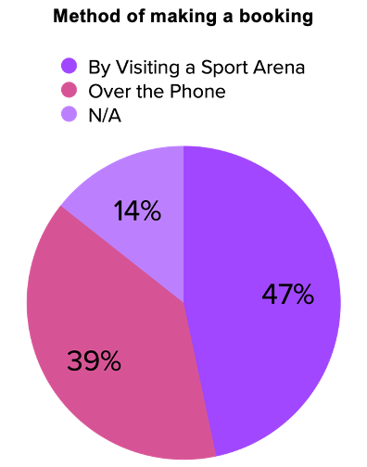

Figure 5: Method of making a booking

Figure 4: Frequency of visiting a sports arena

As per the figure 5, 47% of the customers make the booking by visiting a sports arena and 39% make the booking over the phone. With our proposed platform all the costs incurred on making a booking would be zero for the customers and the customers would be able to make the booking at any time in the day. But in the current context, if the customers are making the booking, they can make the booking only during the working hours of the sport arena. Hence, this statistic also signifies the importance of Sportizza.

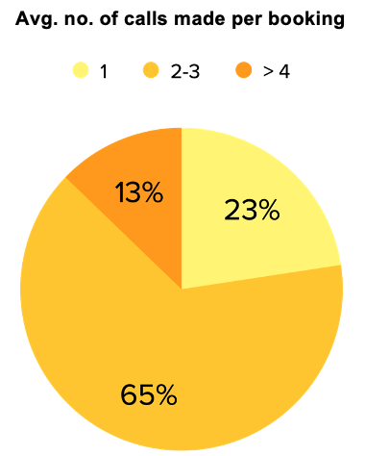

Pie chart with Average number of calls made per booking depicts that 65% of the customers are making around 2-3 calls only to the sports arena to during their booking process. This may include the first call to check the availability and the second calls to make the booking and may be third call to confirm the booking 3 days prior. Also, 13% of the population have to sometimes make more than 4 calls per one booking. Most of the time, this may be when the sports arena cancels the booking due to emergencies. For all these issues, we are proposing one hassle free system for the customers as well as the sports arena.

Figure 6: Avg. no. of calls made per booking

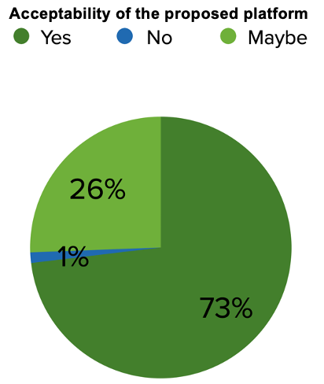

Furthermore, we have also asked the population whether they would like an application which would cater them as a solution for the. Above issues. So, 73% of them responded as “Yes” and 26% responded as “Maybe”.

Figure 7: Acceptability of the proposed platform

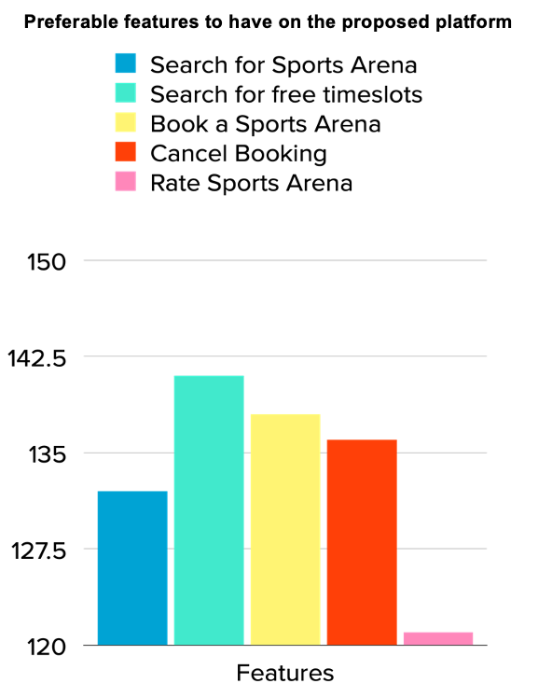

Additionally, we have collected responses on the preferrable features to have on our application. Highlight of this statistic is that more than 140 people out of 1the total responses of 156 would like to have the search for free timeslot feature and more than 135 would like to have book a sports arena feature and booking cancellation features in our platform.

Figure 8: Preferable features to have on the proposed platform

*On a special note, these statistics might not be accurate when it comes to rural areas as the responses were collected mostly from the urban and sub-urban population of Sri Lanka.

***After considering all these facts, it’s clear that our system is socially feasible.***

## 6.5 Economic Feasibility

Since Free & Open-Source Software are used for development, it won’t cost anything related to the development.

When deploying the system, the cost of hosting the web application or for any other hardware equipment would be ideally nil as we are planning to use the EC2 service of the Free tier of “Amazon Web Services” (AWS) to deploy the system. As additional services, we are using the Elasitc Beanstalk Service from AWS and Relational Database Service from AWS. For Domain service, we are using the Cloudflare’s service. Eventually, once the user base grows, the system would be updated to the paid versions which would depend upon the user base. For the SMS module, we use TEXTIT. BIZ’s facility, which shall cost LKR 0.69 per a SMS.

For payment gateway, we are planning to use the “PayHere” sandbox and it’s also freely available at the moment.

***Therefore, our system is economically feasible.***

## 6.6 Schedule Feasibility

The time duration allowed for this project is 10 months. All the work has been divided among the 4 group members and it’s anticipated to finish our project by the end of March 2022. Below is the Gantt chart prepared with respect to our project.

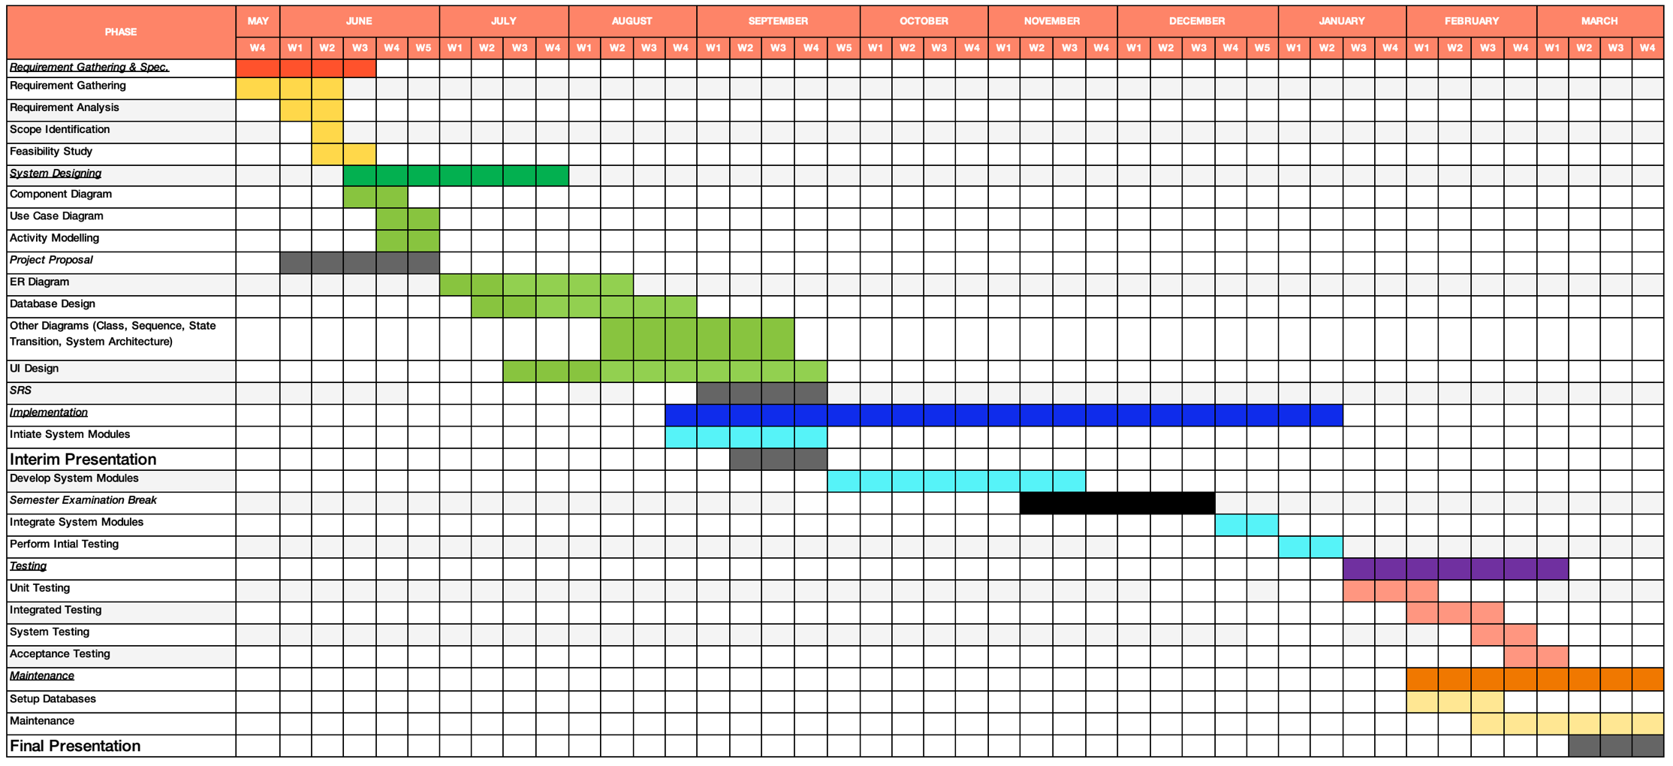

*Figure 9: Gantt Chart*

|  |  |  |
| --- | --- | --- |
| * Number of individual work hours (per week) | = | 10h |
| * Number of work hours as a team (per week) | = | 40h |
| * The estimated number of weeks | = | 30 |
| * The estimated total of man-hours | = | 1200h |
| * Risk buffer | = | 240h |
| * Budgeted Time | = | 1440h |

# Project Constraints and Limitations

* Through the proposed platform, only the registered users would be allowed to make a booking and for that, every customer should have an available mobile phone number for verification process during Signup process.

* Since the authority to choose the payment option is fully granted to the sports arena’s manager and the administration staff, any issues involved with the cash payments aren’t handled and not taken responsibility by the Sportizza platform.
* Also, the customers are not allowed to reschedule their bookings. Instead, the customers could cancel their current booking, if permitted by the guidelines and make a new booking. Customers would receive their refunds within the next 14 days.
* Some other additional features such as providing discount codes by sports arenas to attract customers advertise the sports tournaments organized by the customers and offering a facility to connect customers with relevant coaches are not currently considered under the project due to resource constraints.
* If a sports arena has more than one category of sports facilities (Ex: Having a Cricket ground and a football courts under the same sports arena name), then the sports arena should create distinct accounts for different categories.
* Furthermore, government-controlled sports arenas which don’t allow the customers to book their facilities per a required time slot couldn’t be booked via the Sportizza platform.
* One last limitation of this project would be that we are using the waterfall model to carry out this project as the requirements are stable enough and the industry itself is quite stable over the long term. On the flip side, the use of the waterfall model limits our team from providing frequent deliverables and it would ultimately increase the overall risk of arriving at the most relevant project by the time of deployment. However, we would always be willing to do any changes whenever required even though we use the waterfall model as a framework to structure the timeline of our project development.

# Requirements of the project

## 8.1 Functional Requirements

There are six main actors in the system,

* Visitor
* Customer
* Manager of the sports arena
* Administration staff of the sports arena
* Booking Handling staff of the sports arena
* Admin

Functional requirements according to the actors in the proposed system are stated below:

* + - 1. A visitor has the following functional requirements:
* **Search for sports arenas** – User shall be able to search for sports arena by inputting a date, location, and the sport category or else by directly inputting the sports arena name.
* **Ask help/ support desk** – User shall be able to request any help from the system admin by shooting a message from the Ask help section in the system.
  + - 1. A customer has the following functional requirements:
* **Sign up** – User shall be able to Sign up for a customer account and maintain their profile to make bookings in the future.
* **Login/ Log out** – User shall be able to login and logout whenever they required. User shall be able to use the functionalities of a visitor without logging into the system from their user account.
* **Edit profile details** – User shall be able to edit their profile details including the username, mobile number, first name and last name.
* **Search for sports arenas** – User shall be able to search for sports arena by filtering the location and the sport category or else by directly searching via the sports arena name.
* **Book sports arena** – User shall be able to book (reserve) a timeslot of a particular sports arena for a particular date.
* **Add bookings to the cart** - User shall be able to add multiple bookings from multiple sports arenas and proceed to the payment at once.
* **Do a payment** – User shall be able to do card payments to receive the booking confirmation if the sports arena allows only card payments for the customers. For cash payments’ this functional requirement is not essential.
* **Share booking** – User should be able to share the received booking confirmation via a shareable link generated from the system to the colleagues or the family who visit the sports arena with.
* **Rate sports arenas and provide reviews** – User should provide a star-rating out of 5 stars and also a review about the sports arena facilities after using the facility.
* **Create my favorite sports arenas list** – User could create their favorite sports arena list in their profile so that the user can directly click a sports arena out of it and check for the sports arena and make the booking.
* **Cancel booking** – User shall cancel the booking 72 hours before the start time of the booking timeslot. If paid for the booking by card, refund will be provided to the customer within next 14 days.
* **View my bookings** – User should be able to view their bookings inside their profiles including the past bookings made via Sportizza.
* **Ask help/ support desk** – User shall be able to request any help from the system admin by shooting a message from the Ask help section in the system.
* **Check Notifications** - User shall be able to view the notifications.
  + - 1. The manager of the sports arena has the following functional requirements:
* **Register (Sign up) for an account** – User shall apply to register a sports arena in the platform. User shall also receive one manager account for the sports arena after manual verification of the sports arena by the system admin.
* **Login/ Log out** – User shall be able to login and logout whenever they required. User shall be able to use the functionalities of a visitor without logging into the system from their user account.
* **Edit user profile details** – User shall be able to edit their profile details including the username, mobile number, first name and last name.
* **Edit sports arena profile details** – User shall be able to edit the sports arenas name, contact number and other details including the facilities and services offered.
* **Generate reports** – User shall be able to generate monthly analytical reports with respect to the bookings of the sports arena and the corresponding revenue breakdowns.
* **Choose payment method** – User shall be able to choose the payment method of the sports arena (Cash payments or card payments or both). Sportizza is not bearing any risk involved with the cash transactions.
* **Process cash transactions** – User shall be able to enter the cash transactions related to the bookings made on cash payment method.
* **Booking slots manually** – User shall be able to book time slots on behalf of the customers who visit the sports arenas to make bookings.
* **View bookings** – User shall be able to view all the bookings by selecting a date.
* **Update Time slots**– User shall be able to update future time slot’s status whether they are available or not. However, user is only allowed to update the timeslots which have not yet being booked by any customer. If it’s already booked, then emergency booking cancellation shall come into effect.
* **Emergency booking cancellations** – User shall be able to cancel the existing bookings due to emergency (unavoidable) issues.
* **Manage facilities** - User shall be able to add and remove facilities to sports arena.
* **Creation of User accounts for other staff** - User shall be able to create accounts for other staff members of the sports arena under 2 categories: Administration Staff and Booking Handling Staff.
* **Edit Sports Arena Profile** - User shall be able to edit the sports arena details listed in the profile.
* **Ask help/ support desk** – User shall be able to request any help from the system admin by shooting a message from the Ask help section in the system.
* **Check Notifications** - User shall be able to view the notifications.
  + - 1. Administration Staff of the sports arena has the following functional requirements:
* **Register (Sign up) for an account** – User shall apply to register a sports arena in the platform. User shall also receive one account for the sports arena after manual verification of the sports arena by the system admin.
* **Login/ Log out** – User shall be able to login and logout whenever they required. User shall be able to use the functionalities of a visitor without logging into the system from their user account.
* **Edit profile details** – User shall be able to edit their profile details including the username, mobile number, etc.
* **Choose payment method** – User shall be able to choose the payment method of the sports arena (Cash payments or card payments or both). Sportizza is not bearing any risk involved with the cash transactions.
* **Process cash transactions** – User shall be able to enter the cash transactions related to the bookings made on cash payment method.
* **Booking slots manually** – User shall be able to book time slots on behalf of the customers who visit the sports arenas to make bookings.
* **View bookings** – User shall be able to view all the bookings by selecting a date.
* **Update time slots** – User shall be able to update future time slot’s status whether they are available or not. However, user is only allowed to update the time slots which have not yet being booked by any customer. If it’s already booked, then emergency booking cancellation shall come into effect.
* **Manage facilities** - User shall be able to add and remove facilities to sports arena.
* **Emergency booking cancellations** – User shall be able to cancel the existing bookings due to emergency (unavoidable) issues.
* **Edit Sports Arena Profile** - User shall be able to edit the sports arena details listed in the profile.
* **Ask help/ support desk** – User shall be able to request any help from the system admin by shooting a message from the Ask help section in the system.
* **Check Notifications** - User shall be able to view the notifications.

1. Booking Handling Staff has the following functional requirements:

* **Login/ Logout** – User shall be able to login and logout whenever they required. User shall be able to use the functionalities of a visitor without logging into the system from their user account.
* **View bookings** – User shall be able to view all the bookings by selecting a date.
* **Check Notifications** - User shall be able to view the notifications.

1. Admin has the following functional requirements:

* **Login/ Logout** – User shall be able to login and logout whenever they required. User shall be able to use the functionalities of a visitor without logging into the system from their user account.
* **Remove sports arenas** – User shall be able to remove the sports arena account as well as its respective user accounts if the sports arena don’t abide by the terms and conditions of Sportizza.
* **Remove customers** - User shall be able to remove the sports arena account as well as its respective user accounts if the sports arena don’t abide by the terms and conditions of Sportizza.
* **Remove negative feedbacks after assurance by the sports arena** – User shall be able to remove the negative feedbacks on the sports arenas from the platform after the sport arena assuring the changes have been made as requested by the customers.
* **Help & support** – User shall reply to the inquiries and the issues faced by the other users of the system.
* **Generate System Reports** – User shall be able to generate the system related reports such as the number of active users, amount of network traffic driven to the platform, etc.

### 8.3 Use Case Diagram

Use Case Diagram Assumptions:

* For every sports arena, 3 user account types are privileged namely Manager, Administration Staff and Booking Handling Staff with respective levels of privileges to operate the sports arena’s day-today activities.
* When verifying a sports arena, the admin has to manually verify the details from the sports arena manager or the administration staff and also should do background checks about the details of the sports arena.
* Once a booking is cancelled, refund fee for the customer would be provided after 14 days.

*Due to the complex nature of our system, it is not possible to divide into sub-systems and draw separate use case diagrams based on users. Hence, one comprehensive use case diagram has been drawn.

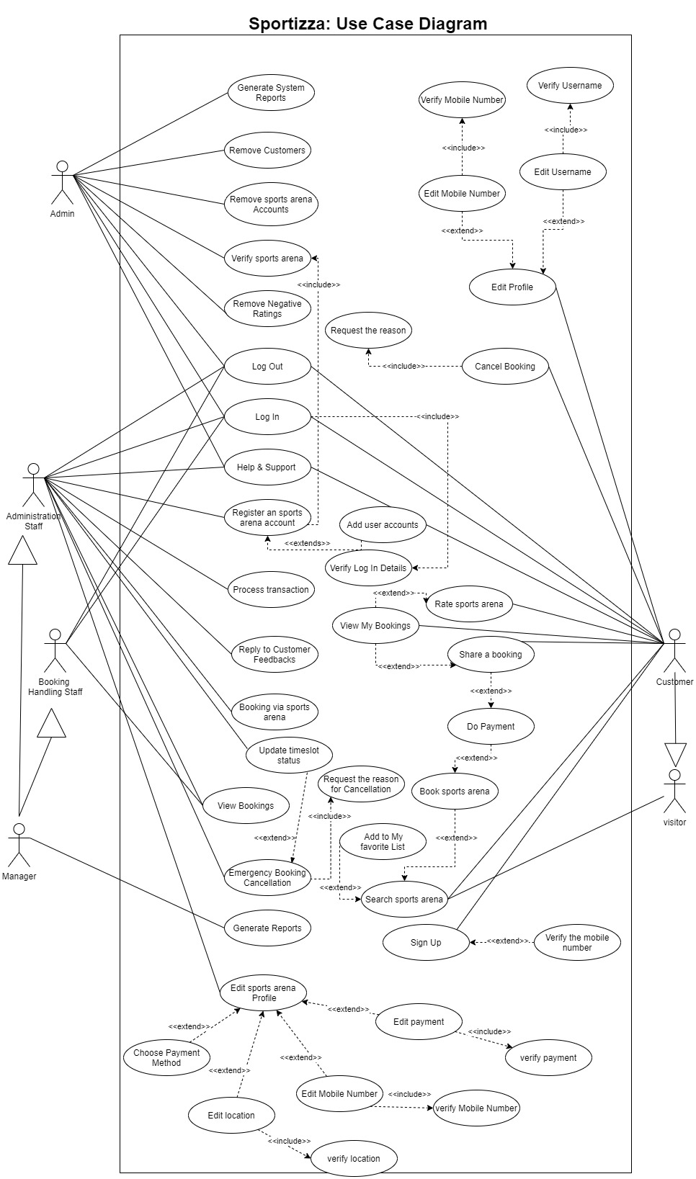

### .5 Use Case Descriptions

|  |  |
| --- | --- |
| Use-Case Name | Sign Up for Customer Account |
| Use-Case ID | 01 |
| Summary | The user can create their profiles. |
| Actors | Visitor |
| Pre-Conditions | The user must visit the platform. |
| Course of Events | 1. The user enters the relevant personal details including the mobile number. 2. Verify the mobile number with a verification code. 3. Activate the user account. |
| Exceptions | If the mobile number entered is invalid, or already has an account with the mobile number, then the user has to try again. |
| Post-Conditions | The user gets redirected to his/her account. |

|  |  |
| --- | --- |
| Use-Case Name | Login |
| Use-Case ID | 02 |
| Summary | User can login to the system |
| Actors | Customer, Book Handling Staff, Administration Staff, Manager, Admin |
| Pre-conditions | User must have an account  User must not be currently logged into the system |
| Course of Events | 1. User clicks the relevant login icon  2. User submits a form displayed with username and password. (For sports arena, they should enter the sports arena name too).  3. System checks whether the username and hash password provided matches with those in the database  4. Start a session |
| Exceptions | If the credentials entered are invalid, an error message pops up |
| Post-conditions | User shall be logged into the system under the relevant privilege. |

|  |  |
| --- | --- |
| Use-Case Name | Edit profile |
| Use-Case ID | 03 |
| Summary | The user can edit profile details |
| Actors | Customer. |
| Pre-Conditions | The user must be currently logged into the system. |
| Course of Events | 1. Go to my profile and select the details the user wants to change. 2. If it's a username, check the availability of the new username. 3. If it’s a mobile number, verify the mobile number via a system generated code. 4. If it’s a password, verify the password. |
| Exceptions | If the user can’t verify, the user can try again. |
| Post-Conditions | If process successful Display “Edit profile is successful” |

|  |  |
| --- | --- |
| Use-Case Name | Search for Sports Arena |
| Use-Case ID | 04 |
| Summary | The user can search for sports arenas and available time-slots. |
| Actors | Visitor, Customer. |
| Pre-Conditions | The user must visit the platform. |
| Course of Events | 1. Enter the Sports Arena name. 2. Enter filters such as category, sports arena, date and perform the search. 3. Display the matched results. 4. Select the preferable time slots. 5. Check the available facilities of the sports arena. |
| Exceptions | Alternatively, can enter the name of the sports arena and search too. The user can select a sports arena and view additional details of that particular sports arena. Furthermore, a user can add a sports arena to my favorite list. |
| Post-Conditions | The user can book a required time slot(s) if it's a customer. |

|  |  |
| --- | --- |
| Use-Case Name | Booking sports arena. |
| Use-Case ID | 05 |
| Summary | The user can book a sports arena. |
| Actors | Customer. |
| Pre-Conditions | The user should be logged in to the search window of the site. |
| Course of Events | 1. The user can view the available time slots.  2. The user can select a booking slot.  3. The user can confirm booking.  4. If the sports arena requires card payments, the system shall redirect the user to the payment gateway. (Cash payments are handled after using the facilities).  5. User’s mobile shall receive an SMS with the booking details. |
| Exceptions |  |
| Post-Conditions | After booking a slot, if the sports arena allows only card payments, the user shall get directed to the payment gateway. Else, the user can share the booking details with the friends via social media. |

|  |  |
| --- | --- |
| Use-Case Name | Do Payment |
| Use-Case ID | 06 |
| Summary | The user can perform a payment to confirm the booking. |
| Actors | Customer. |
| Pre-Conditions | The user should select an available time slot. |
| Course of Events | 1. The customer enters the relevant card details. 2. Relevant amount gets transferred to the system’s account. (Every two-weeks, all due amounts are credited to the sports arenas’ accounts. 3. The customer receives a notification “payment successful”. |
| Exceptions | The transaction might get declined if the card details are invalid or due to insufficient balance. Also after 2 minutes, the payment window gets expired (Timed out). |
| Post-Conditions | The user shall get the option to share the booking details with friends via social media. |

|  |  |
| --- | --- |
| Use-Case Name | Share booking |
| Use-Case ID | 07 |
| Summary | The user can share a booking via social media. |
| Actors | Customer |
| Pre-Conditions | The user should have made a booking via the site. |
| Course of Events | 1. The user could select the share option respective to the booking. 2. Alternatively, the user can click to share my booking after successfully completing a payment with the respective booking. 3. The user can select the respective social media platform and share it with the relevant parties. |
| Exceptions | Sharing might get declined if a valid social media account doesn’t exist. |
| Post-Conditions | The user gets redirected to his/her account. |

|  |  |
| --- | --- |
| Use-Case Name | Cancel Booking |
| Use-Case ID | 08 |
| Summary | The user can cancel booking and must enter the reason for cancelling reason |
| Actors | Customer. |
| Pre-Conditions | User must be currently logged into the account  Booking must have at least three days (72 hours) for the booking day before cancellation. |
| Course of Events | 1. User can select the booking from my booking list 2. Click cancel booking icon 3. Enter the reason for cancellation 4. System sends a verification code 5. Enter verification code 6. Display refund information 7. System changes the booking slot an available time slot. |
| Exceptions | If the user couldn’t enter a valid verification code, the user can try again. If it’s a cash transaction, no refund is made. |
| Post-Conditions | If process successful Display “cancel booking is successful”.  If not successful display “You are not allowed! You have passed the cancellation period”. |

|  |  |
| --- | --- |
| Use-Case Name | Rate Sports arena |
| Use-Case ID | 09 |
| Summary | The user can provide a rating to a sports arena. |
| Actors | Customer |
| Pre-Conditions | The customer should have done a booking for a particular sports arena and the customer should have used its service. |
| Course of Events | 1. After the finish time of the booked time slot, the site pop up with a feedback sheet. 2. If clicked the cancel button at that time, the user can alternatively view his/her past bookings over my bookings segment in their profile and select the rating option from the booking. 3. The user can click and provide a star-rating. 4. Optionally, the user can enter any feedback too. 5. The user could submit the feedback or alternatively cancel the option. |
| Exceptions |  |
| Post-Conditions | Customer rating shall get added to the sports arena’s profile and to the average rating of that sports arena. |

|  |  |
| --- | --- |
| Use-Case Name | Help & Support |
| Use-Case ID | 10 |
| Summary | After an administration staff, manager or a customer posts an issue, the admin shall follow the issue and shall provide necessary solutions. |
| Actors | Administration Staff, Manager, Customer, Visitor, Admin |
| Pre-Conditions | A complete and reasonable issue must be available. |
| Course of Events | 1. The user can post their issues if it's not answered on the site under FAQs. 2. The user gets notified that the question is successfully posted. 3. Admin shall get notified about the posted issue. 4. If it’s a new complaint, generate a complaint reference number. 5. System sends the complaint reference number. 6. Admin shall provide necessary solutions. 7. The user shall get notified with the solution for their issue. |
| Exceptions | If any such similar issue is not available under the FAQs, Admin can add the questions to the FAQs depending on the relevance. |
| Post-Conditions | The issue shall be marked as answered. |

|  |  |
| --- | --- |
| Use-Case Name | View My Bookings |
| Use-Case ID | 11 |
| Summary | Customer can view their bookings through their profile. |
| Actors | Customer |
| Pre-Conditions | The user must be logged in to the system. |
| Course of Events | 1. User can go my profile. 2. Select My bookings. |
| Exceptions |  |
| Post-Conditions | The user shall get directed their profile once the back button is clicked. |

|  |  |
| --- | --- |
| Use-Case Name | Register a Sports Arena account |
| Use-Case ID | 12 |
| Summary | Authorized people from a particular sports arena can create their respective sports arena’s profiles. |
| Actors | Administration Staff, Manager, Admin |
| Pre-Conditions | The user must not have a listed sports arena with the same name and address under the same category. |
| Course of Events | 1. User enters the details of the sports arena including name, address of the sports arena, category of sport(s), equipment availability, other facilities, payment option, etc. 2. Submit the application. 3. Admin clicks on the applied sports arena application. 4. Contact the sports arena. 5. Verify the sports arena via Google Maps and other methods. 6. Accept the sports arena account if successfully verified. 7. List the account on site. 8. User has the option to add user accounts to the sports arena account. |
| Exceptions | If sports arena’s details aren’t properly verified, quit the process, and notify the applicants. Applicants could try again. |
| Post-Conditions | The user shall get notified once the sports arena is listed on the site after the manual verification process and shall get re-directed to the homepage. |

|  |  |
| --- | --- |
| Use - case Name | Edit Sports Arena Profile |
| Use - case ID | 13 |
| Summary | User edits the details, pictures, and features(facilities) in the profile. |
| Actors | Manager, Administration Staff |
| Pre-conditions | The user must be currently logged into Edit Window in the system. |
| Course of Events | 1. Select the Detail to want to change 2. Change the detail 3. Verify the validity of the detail 4. Save and end the session 5. User receives successful notification |
| Exceptions | If the changing detail is not valid, then the user can try with a different value. If the user going to change the sports arena address, that cannot be done and get a notification to delete the profile and create a new profile. |
| Post-conditions | User gets redirected to the sports arena profile. |

|  |  |
| --- | --- |
| Use - case Name | Make Bookings via Sports Arena |
| Use - case ID | 14 |
| Summary | The user can book a time slot manually. |
| Actors | Manager, Administrations Staff |
| Pre-conditions | The user must be currently logged into the system.  The time slot must be free. |
| Course of Events | 1. View Booking slots. 2. Select the time slot. 3. Enter the customer details. 4. Get the payment (optional). 5. Book the time slot. 6. Send the Notification. |
| Exceptions | If the time slot is not free, the booking cannot be done. |
| Post-conditions | User gets redirected to the sports arena profile. |

|  |  |
| --- | --- |
| Use - case Name | View Booking |
| Use - case ID | 15 |
| Summary | The user views the bookings. |
| Actors | Manager, Administrations Staff, Booking handling Staff |
| Pre-conditions | The user must be currently logged into the system. |
| Course of Events | 1. Select view Bookings. 2. Filter the Bookings (optional). 3. Generate the Booking Table. |
| Exceptions |  |
| Post-conditions | User gets redirected to the sports arena profile. |

|  |  |
| --- | --- |
| Use - case Name | Emergency Booking Cancellation |
| Use - case ID | 16 |
| Summary | The User cancels the booking, because of an emergency |
| Actors | Manager, Administration Staff |
| Pre-conditions | The user must be currently logged into the System. |
| Course of Events | 1. Go to bookings 2. Select the Time period / Date. 3. Select the Booking. 4. Enter the reason for Cancellation. 5. Cancel the Bookings. 6. When canceling the booking, send a notification to the customers. |
| Exceptions | If the reason is not submitted, the booking cancellation cannot be done. |
| Post-conditions | User gets redirected to the sports arena profile.  Remove the sports arena from the search listings for that particular time period. |

|  |  |
| --- | --- |
| Use - case Name | Reply Customer Feedbacks |
| Use - case ID | 17 |
| Summary | The user reply to the feedback of the customers. |
| Actors | Manager, Administration staff |
| Pre-conditions | The user must be currently logged into the system.  There should be a valid feedback. |
| Course of Events | 1. Go the customer feedbacks 2. Select the relevant feedback 3. Reply to the feedback |
| Exceptions |  |
| Post-conditions | User gets redirects to the feedback page. |

|  |  |
| --- | --- |
| Use - case Name | Generate Reports |
| Use - case ID | 18 |
| Summary | The ground manager can get the reports |
| Actors | Manager |
| Pre-conditions | The user must be currently logged into the System. |
| Course of Events | 1. Select the relevant time period. 2. Select the statistics. 3. Obtain the generated reports. |
| Exceptions |  |
| Post-conditions | User gets redirected to the sports arena profile. |

|  |  |
| --- | --- |
| Use-Case Name | Process Transaction |
| Use-Case ID | 19 |
| Summary | User can confirm cash payment |
| Actors | Administration Staff, Manager |
| Pre-conditions | There should be a booking made on cash payment |
|  | User must be logged into the system |
| Course of Events | 1. User should go to profile and view bookings |
|  | 2. Filter bookings with cash transactions |
|  | 3. Save the booking |
|  | 4. A popup appears to confirm the transaction |
|  | 5. If yes, then display transaction successful |
| Exceptions |  |
| Post-conditions | The booking details table gets updated |

|  |  |
| --- | --- |
| Use-Case Name | Update Time Slot Status |
| Use-Case ID | 20 |
| Summary | User can update time slots. |
| Actors | Administration Staff, Manager |
| Pre-conditions | There should be an existing time slot. |
| Course of Events | 1. User views the booking slots and selects one or more slots |
|  | 2. Click update time slots |
|  | 3. A pop-up appears to confirm the process |
|  | 4. If yes, end the session |
| Exceptions | If there is a booking available on any selected time slot, trigger 'Emergency Booking Cancellation' process. |
| Post-conditions | The selected time slots will be displayed as unavailable in the system. |

|  |  |
| --- | --- |
| Use-Case Name | Remove Negative Ratings |
| Use-Case ID | 21 |
| Summary | Admin can remove negative ratings of the sports arena |
| Actors | Admin |
| Pre-conditions | Admin must be currently logged into the system.  A sports arena should have negative reviews. |
| Course of Events | 1. User checks on the negative reviews of the sports arena.  2. User contacts sports arena to inform them.  3. Wait until the changes mentioned are done.  4. After confirmation, remove the ratings |
| Exceptions | If the changes are not made within the requested time period, then blacklist the sports arena. |
| Post-conditions |  |

|  |  |
| --- | --- |
| Use-Case Name | Remove Sports Arena Account |
| Use-Case ID | 22 |
| Summary | Admin can remove sports arenas |
| Actors | Admin |
| Pre-conditions | There should be an existing sports arena account.  The user should be logged in to the system.  The sports arena account should be blacklisted. |
| Course of Events | 1. View complaints of a Sports Arena.  2. If the sports arena is in blacklist, remove the account.  3. Admin clicks on the sport arena profile.  4. Remove account.  3. Notify the sports arena. |
| Exceptions | If the sports arena is not in blacklist, notify the sports arena without removing. |
| Post-conditions | The sports arena would be removed from the system |

|  |  |
| --- | --- |
| Use-Case Name | Remove Customers |
| Use-Case ID | 23 |
| Summary | Admin can remove customer accounts |
| Actors | Admin |
| Pre-conditions | A customer not abiding by the terms & conditions. |
| Course of Events | 1. Admin clicks on the customer account to be removed.  2. Remove the customer account.  3. Notify the customer via an SMS. |
| Exceptions |  |
| Post-conditions | Removed customer would no longer be a customer of the system. |

|  |  |
| --- | --- |
| Use-Case Name | Logout |
| Use-Case ID | 24 |
| Summary | User can log out of the system |
| Actors | Customer, Book Handling Staff, Administration Staff, Manager, Admin |
| Pre-conditions | User must be currently logged into the system. |
| Course of Events | 1. User clicks the logout icon  2. A pop-up appears to ensure logout  3. End the session |
| Exceptions | If the process is cancelled, system redirects user to the current page. |
| Post-conditions | User is logged out of the system |

|  |  |
| --- | --- |
| Use-Case Name | Generate System Reports |
| Use-Case ID | 25 |
| Summary | User can generate system related reports. |
| Actors | Admin |
| Pre-conditions | User must be currently logged into the system. |
| Course of Events | 1. User goes to his/her profile  2. Select type of report to be generated  3. Click the generate report icon  4. System generates and displays the report. |
| Exceptions |  |
| Post-conditions | User gets redirected to the profile. |

## 8.2 Quality Attributes

### 8.2.1 Security

Since security plays a vital role on our platform, we are planning to secure it as much as possible. These are some of the techniques that we are going to use, to improve our security.

* User based authentication is incorporated into login system with access controls to prevent unauthorized access from the sports arena’s end.
* During the signup scenario, user is authenticated by sending am OTP code as a SMS.
* For Login scenarios, PHP’s Salted Hashing technique used.
* JavaScript validation is used for all the front end validations in all the forms of Sportizza.
* Session fixation attacks are prevented by generating separate session IDs for the users.
* PHP Data Objects are used in the backend to prevent SQL injections.
* OpenSSL certification is used as a measure of cryptography.
* The system’s back-end servers shall only be accessible to authenticated administrators.
* For the payments, a well recognised secured third-party service is used.
* All the data stored in the database is encrypted.

### 8.2.2 Availability

Our system should be available at all times, except during the system maintenance period and system downtime period. Since we are planning to use AWS hosting service, it guarantees a 99% availability on Sportizza. By accounting to few other anticipated issues, we would call our system is available 95%. The users can access the platform via a web browser with a mobile device or a personal computer or rather a laptop. In case of hardware corruption, backups of the database are retrieved from the server and saved by the system administration. Hence, our platform would be ideally 24 * 7 available.

8.2.3 Modifiability

We are planning to achieve the modifiability of the web application by enhancing the source code readability. Because in the future, maybe the programmers who wrote a particular piece of code, shall not be available for maintenance of the system. Enhancing the readability shall make it easier to maintain the system for anyone. Using the best coding practices such as commenting, using meaningful identifier/function names and using consistent indentations are our targets. And also, we are planning to develop components of the system with minimal coupling from each other. So, whenever someone wants to modify the system, it would be much easier because it shall not affect the entire architecture.

On the flip side, there can also be situations where our system is not scalable and modifiable with the growing user base. In such scenarios, we would go for a new system which could handle all the required level of facilities and infrastructure.

### 8.2.4 Performance

The platform is a progressive web application. Hence the platform is loaded on top of a web browser. Therefore, the initial load time of the platform would depend upon the internet connection strength. Furthermore, it could also depend upon the device used by the user. Furthermore, since Sportizza is. PWA, offline caching helps the app to provide basic functionalities without an internet connection too.

Also, the system should not crash when too many users are performing searches simultaneously and making booking simultaneously. We shall be using the Amazon Web Services platform to automatically change the specifications of the servers to adhere to the traffic load.

### 8.2.5 Usability

Since the user base contains customers as well as sports arenas, they would prefer simple and easy to use user Interfaces that would give them a better understanding of the system and make the system easy to use.

Furthermore, we have a separate feature called the “Contact Us” feature which is available for any user to post their questions and the system admin would provide solutions to those issues and would add them to the FAQs section if those asked questions are not covered in the current FAQ list. Also, the system has navigation bars, meaningful icons and tools that enhance the user-friendliness of the system.

Figure 12: Use Case Diagram for Sportizz

# Design Specifications

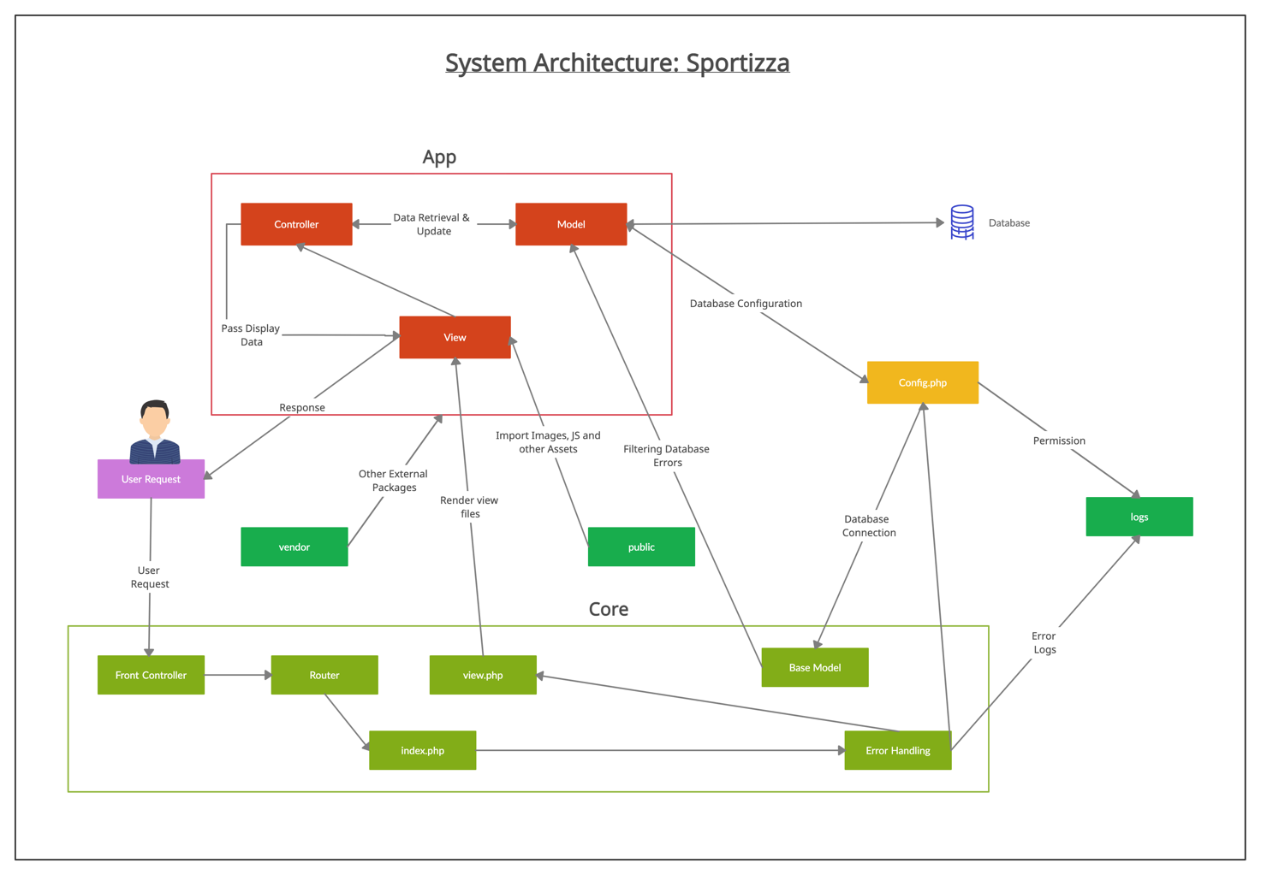

### 9.1 Component Diagram



### 9.2 Individual Components & their responsibilities

### 9.2.1 User Subsystem





The user subsystem consists of main components such as Signup, Login, Logout, Manage Profile & User deletion.

* **Signup** component is responsible for the registration process. It allows the customer & the esports arena manager to enter the required fields and validate those data entered by them with the help of User Creation component. **User Creation** component is responsible in creating a user in the system, it checks the data given by the user and the username is checked against the user table from the database to make sure the user is already not registered. Then it validates the data provided by the customer and send the verification SMS to the user.
* **Login** subsystem consists of all the general components used for Sportizza users such as Login, Forgot Password, User Authentication & User Notification. Login component is responsible for checking the login credentials (username and password) from the user and get those credentials verified from User Authentication component and redirect the user to particular user interface or provide error messages if the credentials are not matched or empty fields or any other possible error. Once a user successfully logs in, a session ID is created to the user with **Session Management**. **Forgot Password** component is responsible to let the user to reset his forgotten password by entering his username & mobile number. The component checks the given user name with User Authentication component and then send the password reset message if the username is verified. Unless, it displays the relevant error messages. User notification component involves in sending all the booking confirmation notifications, booking cancellation notifications, refund policy notifications, etc.
* **Logout** component is responsible for successfully logging out the user. It involves in ending the user session.
* **Manage Profile** component is responsible for updating the user profile. User can update their profile details such as profile picture, first name, last name, password, etc.
* All the users of the Sportizza gets inherited with the components of the User subsystem.

### 9.2.1 Customer Subsystem



The customer Subsystem consists of **Favorite List** component & **My Bookings** Component.

* **Favourite List** component is responsible for the managing the customers’ favorite list of sports arenas. It allows the customers to add & remove a sports arenas from their favorite list.
* **My Bookings** component is responsible for the managing the customers’ bookings. It allows the customers to cancel the bookings, remove old bookings and search their bookings.

### 9.2.1 Sports Arena Subsystem



The sports arena subsystem consists of main components such as Sports Arena Creation, Time slot & Sports Facility components.

* **Sports Arena Creation** component is responsible for creating a sports arena in the system, it checks the data given by the user and the username is checked against the user table from the database to make sure the user is already not registered. Other than basic validations, a manual validation process is carried out before listing the sports arena in the platform.
* **Time Slot** component is responsible for managing the timeslots of the sports arenas. It includes adding timeslots, removing timeslots & updating timeslots.
* **Facility** component is responsible for managing the facilities of the sports arenas. It includes adding facility, removing facility & updating facility details of the sports arena.

### 9.2.1 Sports Arena Staff Subsystem



The sports arena staff subsystem consists of 3 main components. They are Manager, Administration Staff & Booking Handling Staff.

* **Manager** component is responsible for providing all the functionalities to the sports arena manager. Manager component requires services from other components to carry out its tasks such as Add staff, remove staff, manage sports arena, Manage bookings, Manage Cash transactions & get sports Arena Reports.
* **Administration Staff** component is responsible for providing all the functionalities to the sports arena administration staff. Administration Staff component requires services from other components to carry out its tasks such as Manage sports arena, manage bookings & Manage Cash transaction.
* **Booking Handling staff** component is responsible got providing the view booking function to the sports arena booking handling staff.

*In addition to the above required interfaces, all the staff gets inherited from the User component.

### 9.2.1 Booking Search Subsystem



The Booking search subsystem consists of 2 components. They are Time slot & Cart.

* **Timeslot** component is responsible allocating the timeslot for a particular customer, deallocate the timeslot & provide the available timeslots to the customers.
* **Cart** component is responsible for managing the customer cart’ functionalities such as adding timeslots to cart, removing timeslots from the cart & proceeding to checkout.

### 9.2.1 Report Generation Subsystem



The report generation subsystem consists of 2 main components. They are System Reports component & Sports Arena Reports.

* **System Reports** component is responsible for generating the system reports to the admin of the system. Based on the requested type of the data, the sports arena report component will generate it with relevant analytics.
* **Sports Arena Reports** component is responsible for generating the sports arena reports to the sports arenas’ manager. Based on the requested type of the data, the sports arena report component will generate it with relevant analytics.

### 9.2.1 Payment Subsystem



The payment subsystem consists of 3 main components. They are Card component, Cash component & Refund Handling component.

* **Card** component is responsible for directing the user to the payment gateway after finalizing the total bill amount for the customer.
* **Cash** component is responsible for handling all the cash payments done by the Sportizza customers. Sports arenas’ manager & Administration staff use this component’s facility to Manage Cash transactions of their respective sports arena.
* **Refund Handling** component is responsible for handling the customer refunds after booking cancellations. Checking whether the customer is eligible for the refund policy and obtaining their bank details to payback are handled by this component.

### 9.2.1 Security Subsystem



The security subsystem consists of 2 main components. They are Authentication component & Cloudflare component.

* **Authentication** component is responsible for maintaining the integrity of Sportizza data by preventing the unknown third parties from modifying Sportizza data.
* **Cloudflare** component is responsible for providing the added security to the system from by having an openSSL certificate to Sportizza along with Secured HTTP.

### 9.2 Class Diagram

### 9.3 Entity Relationship Diagram

### 9.4 Sequence Diagrams

#### 9.6 Activity Diagrams

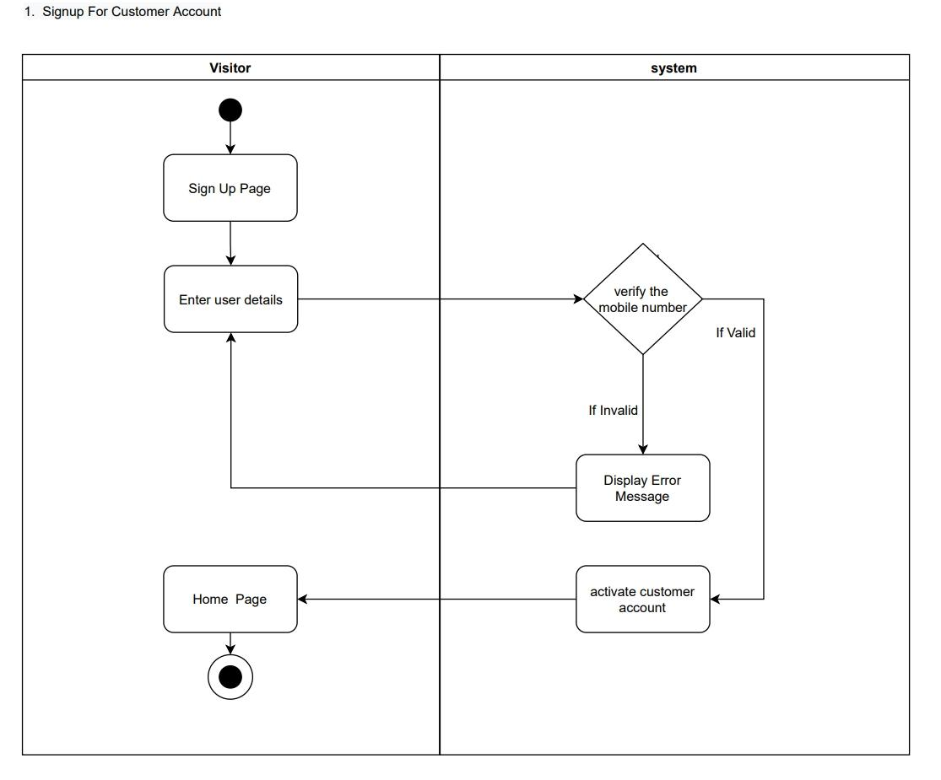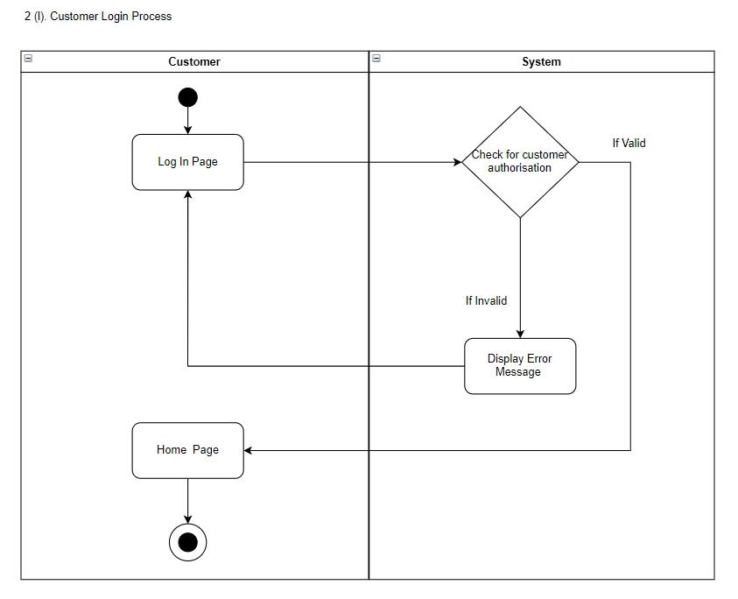

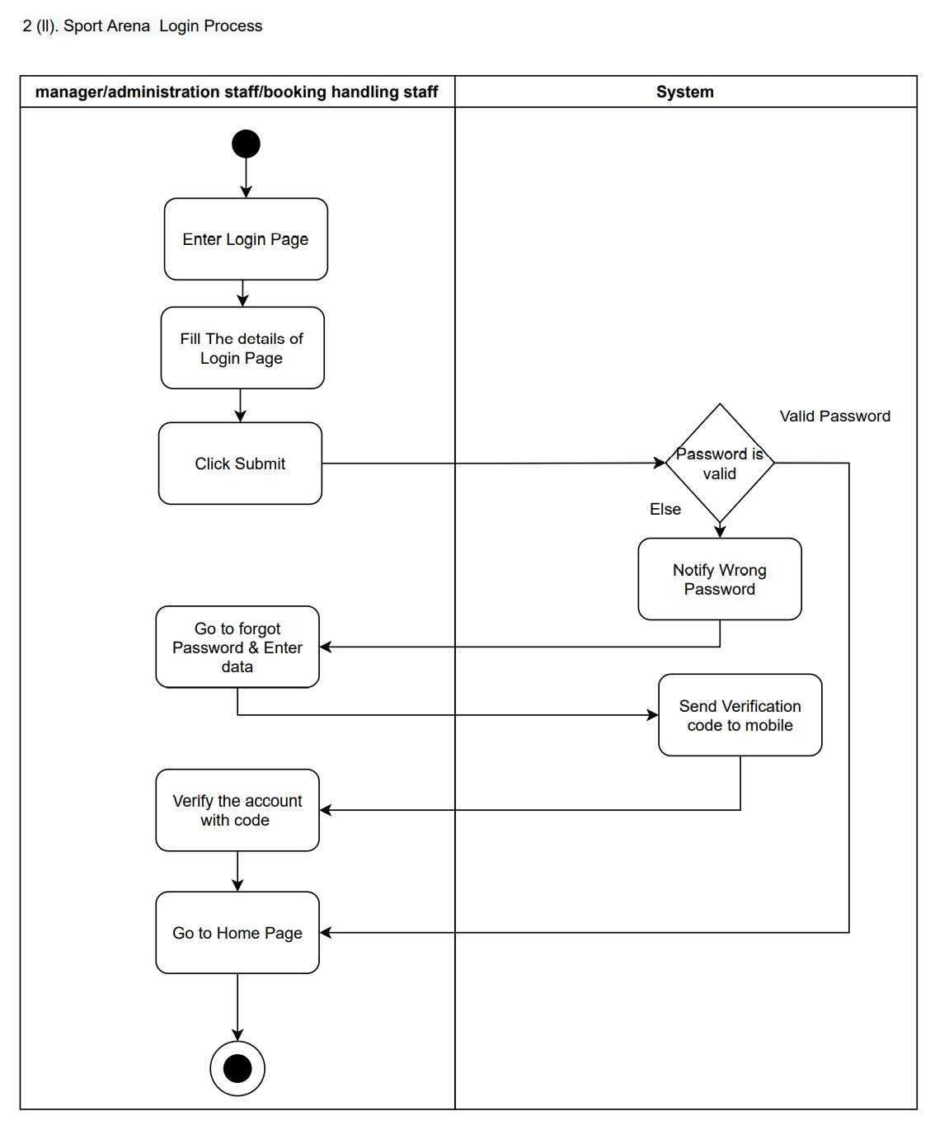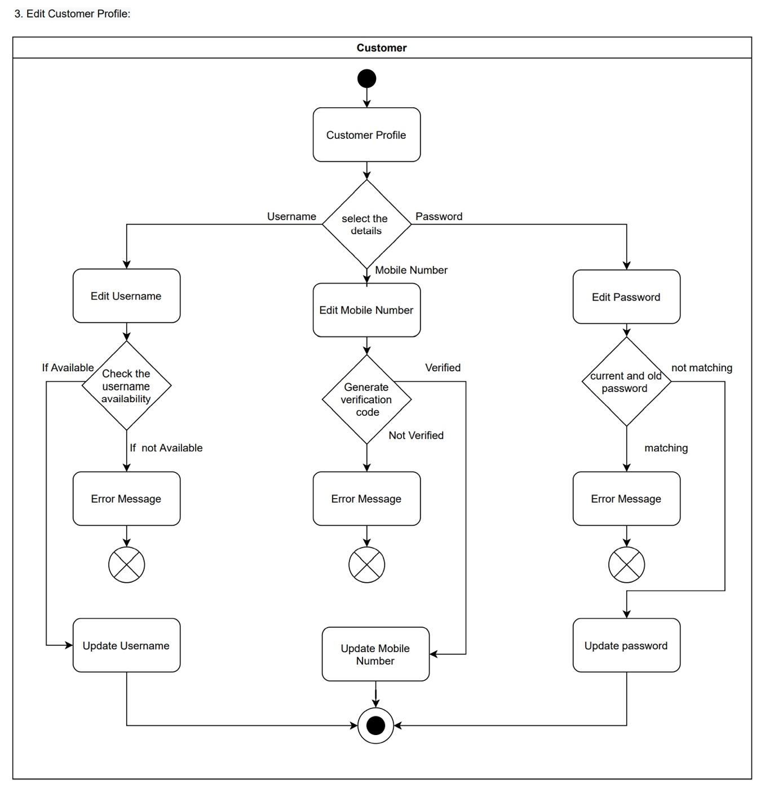

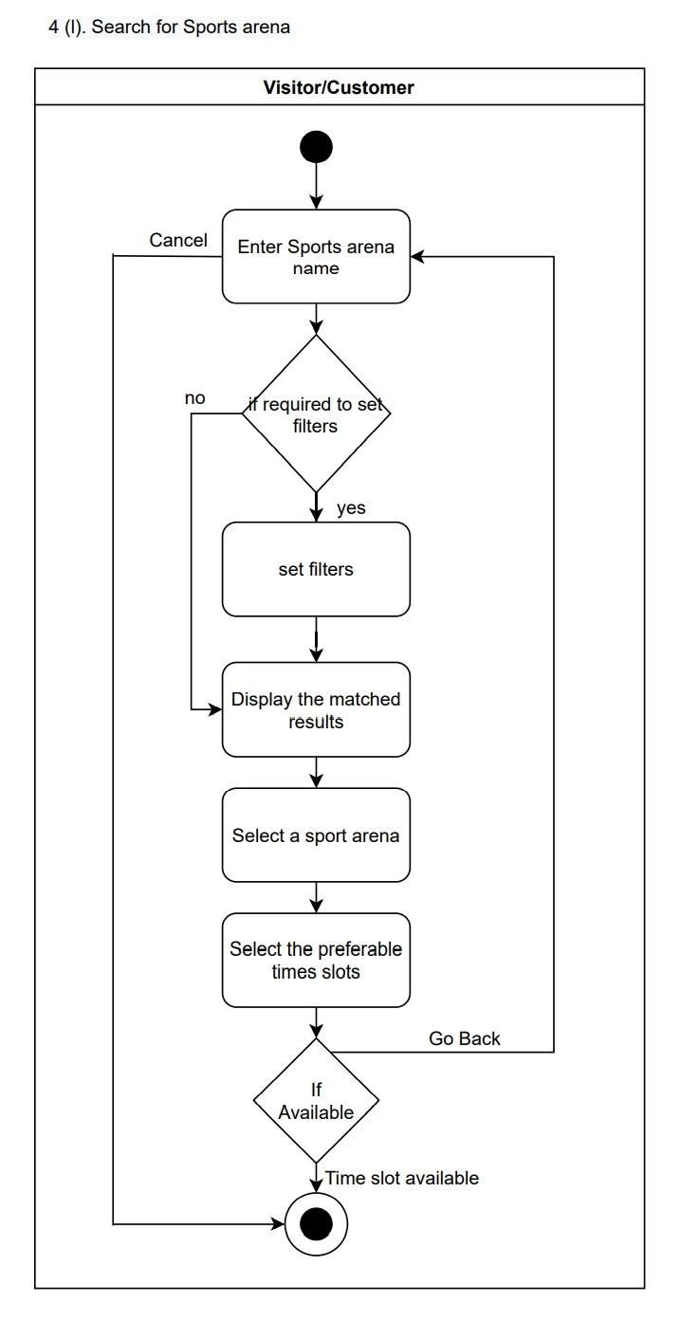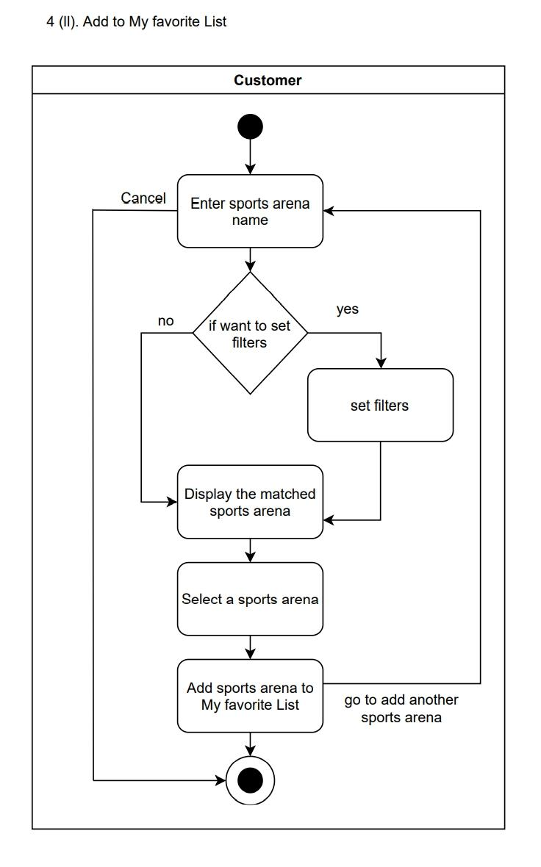

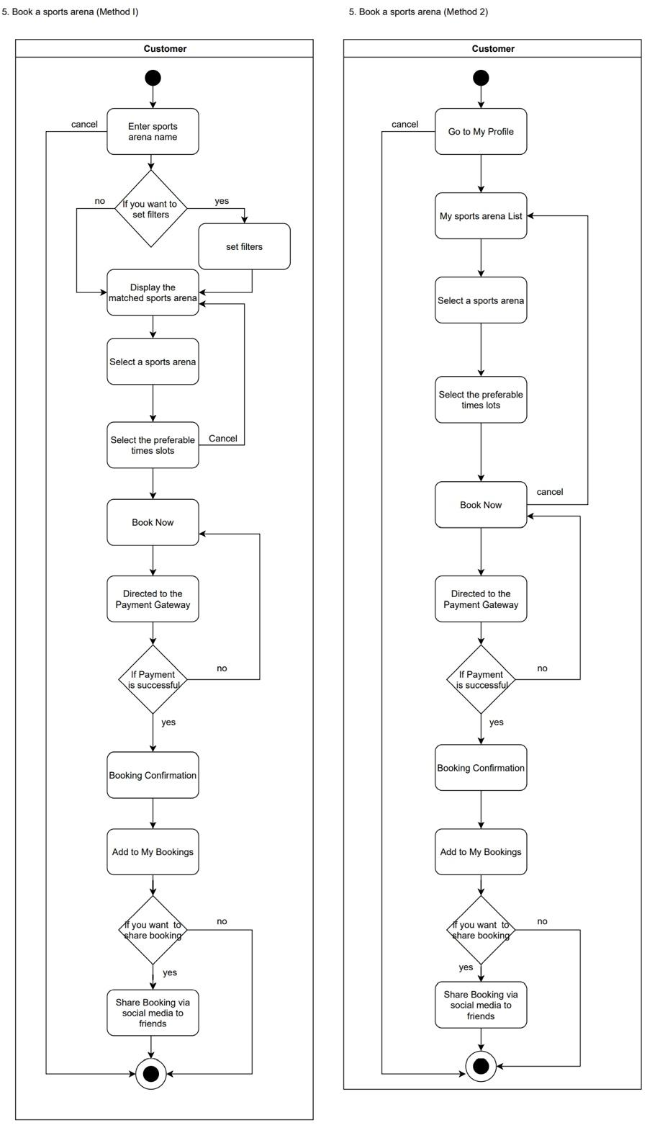

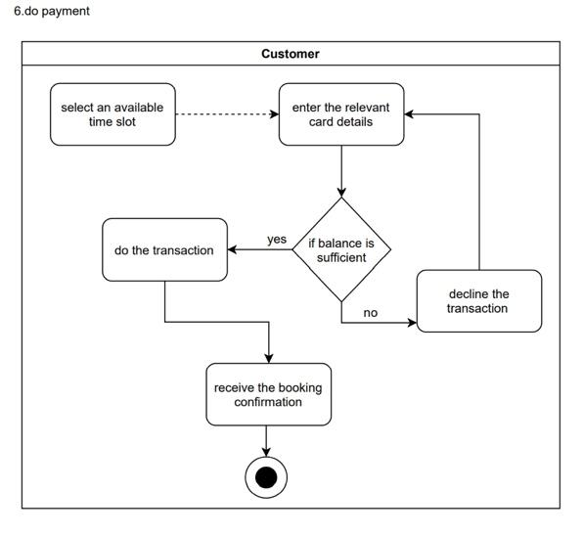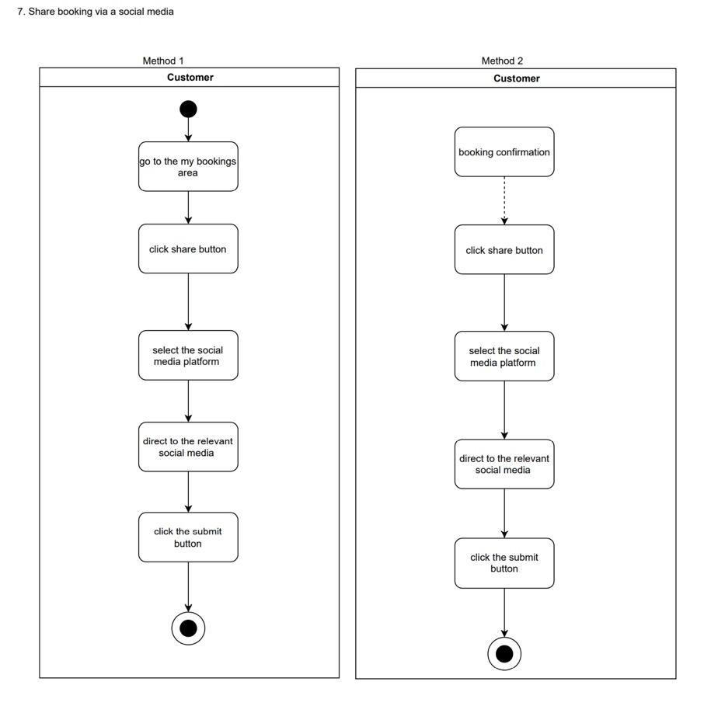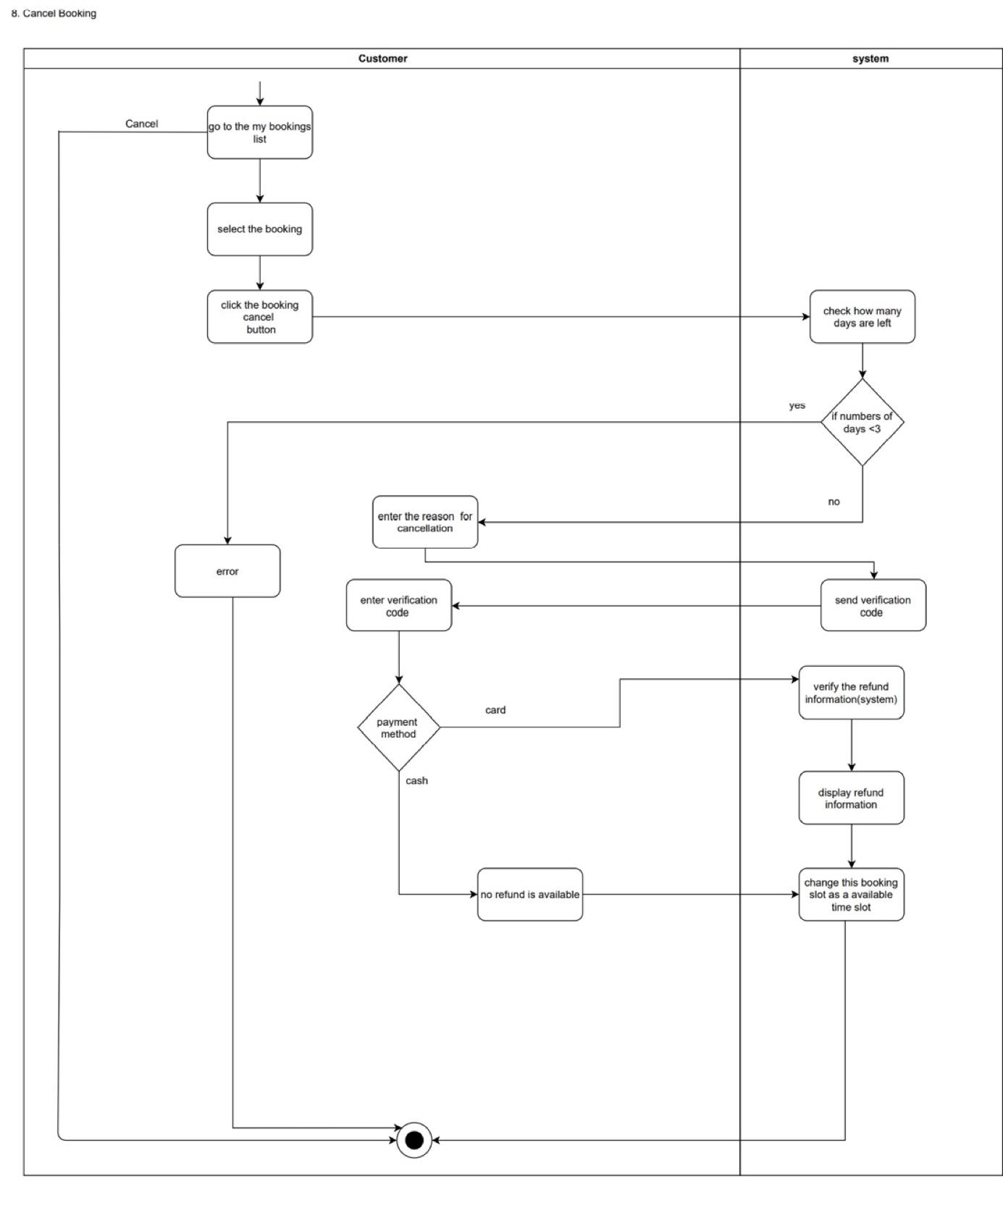

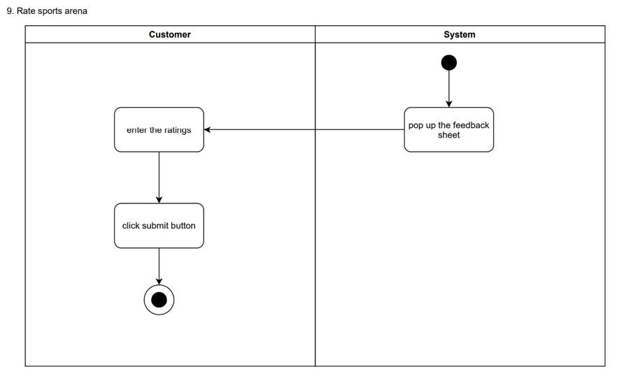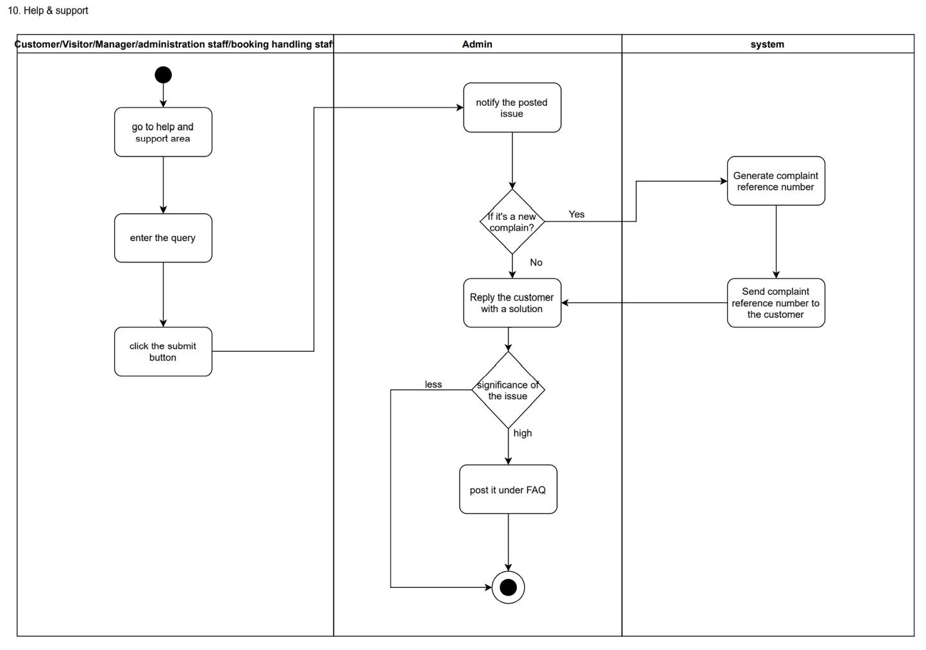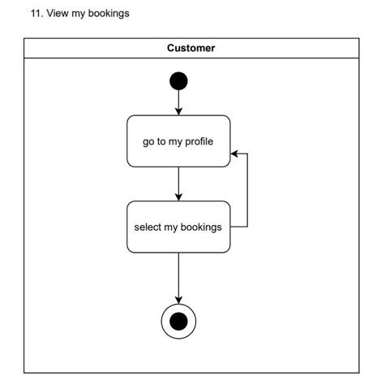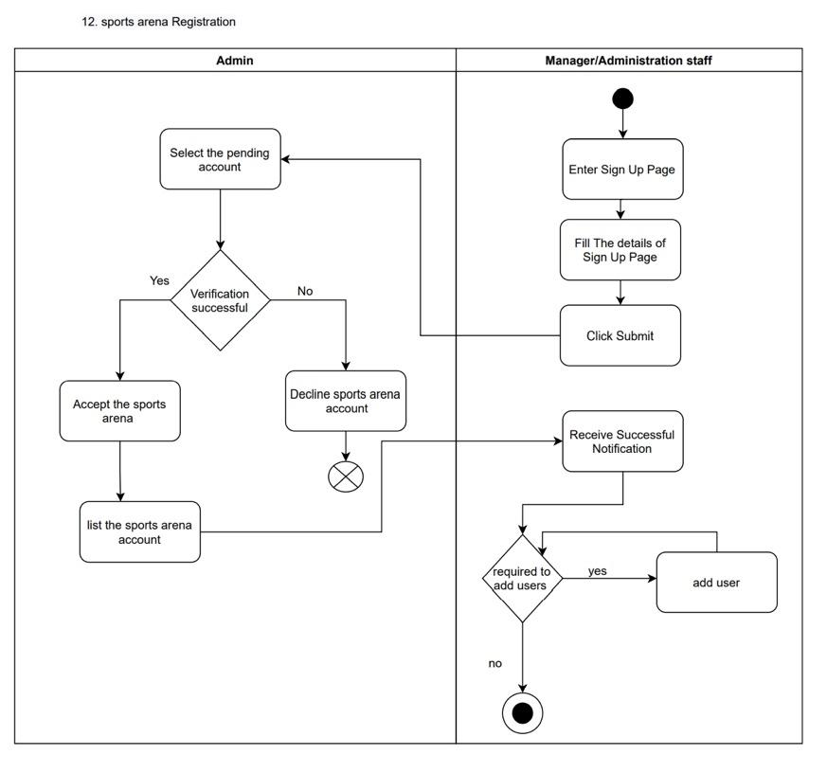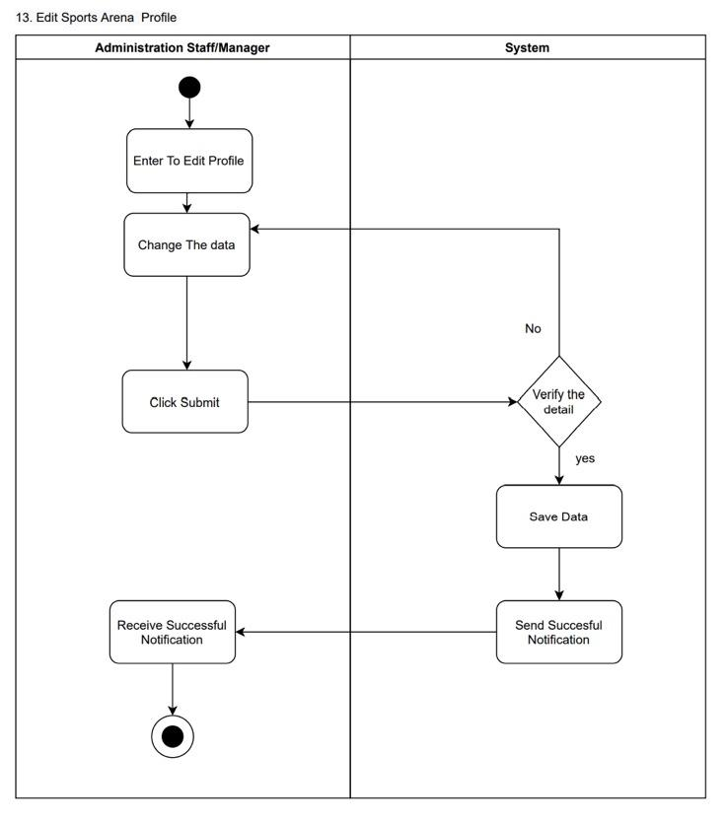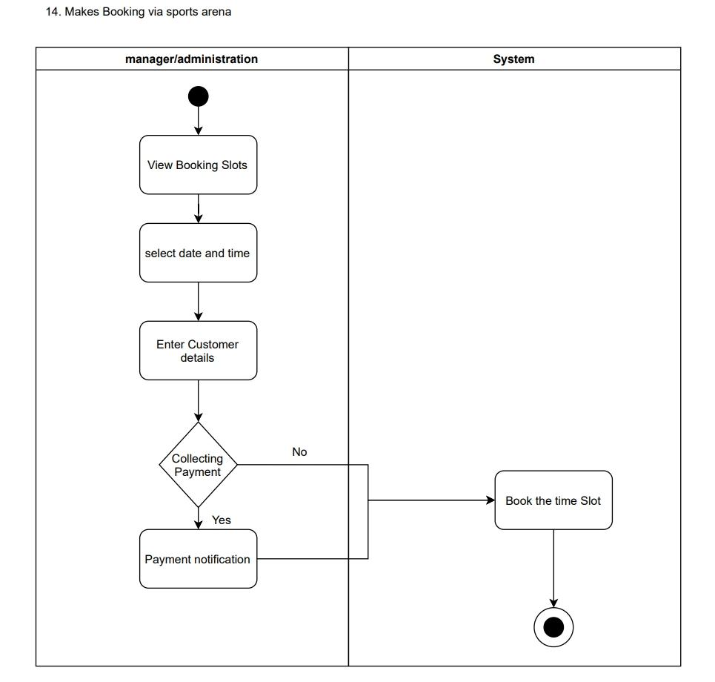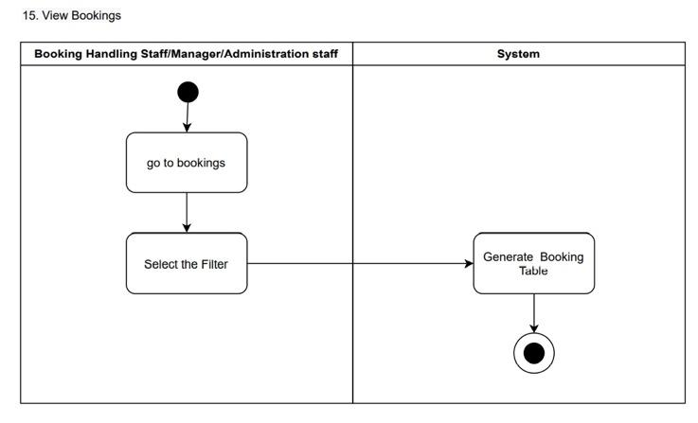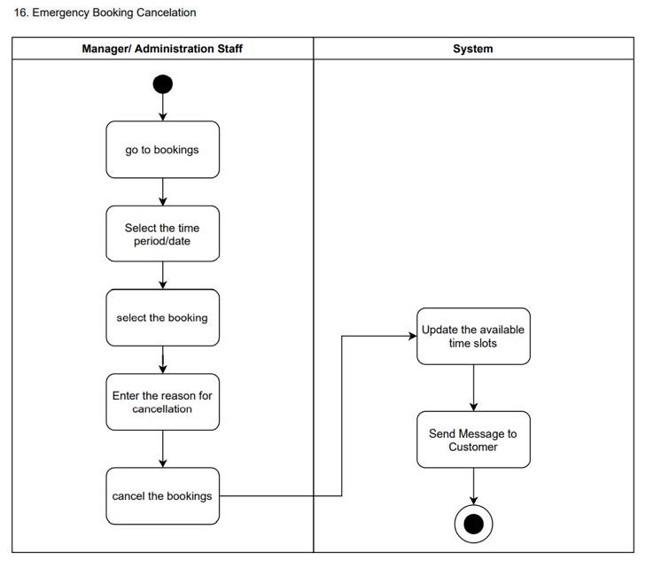

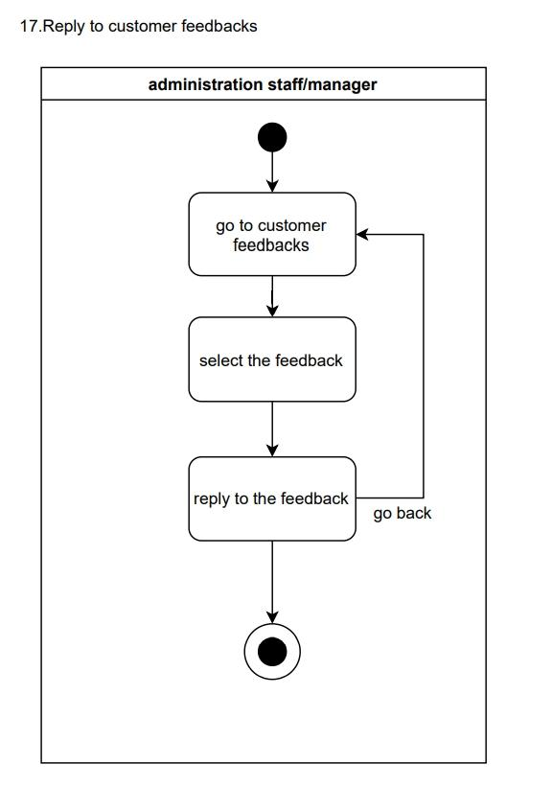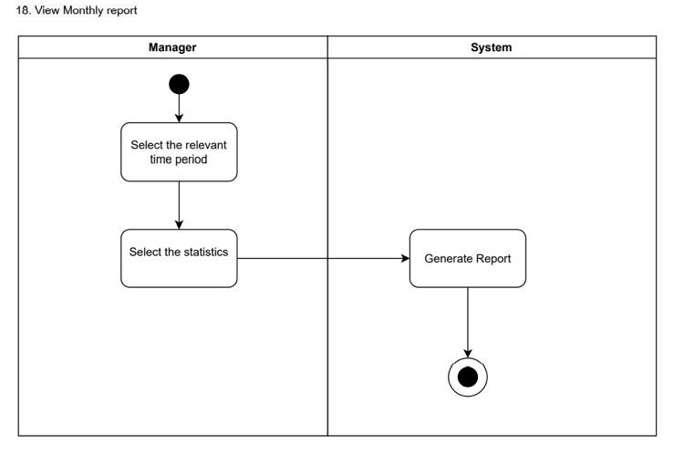

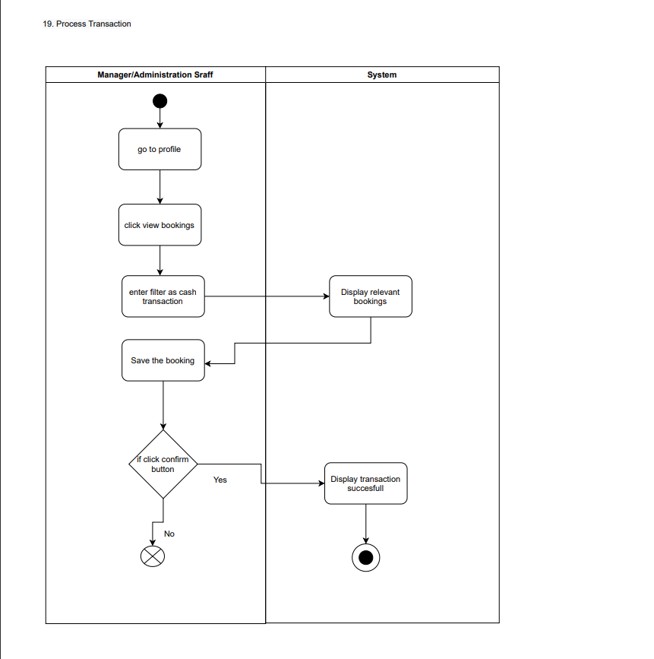

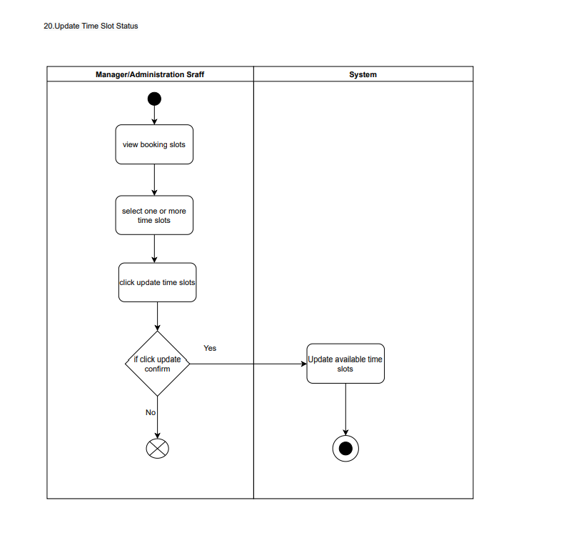

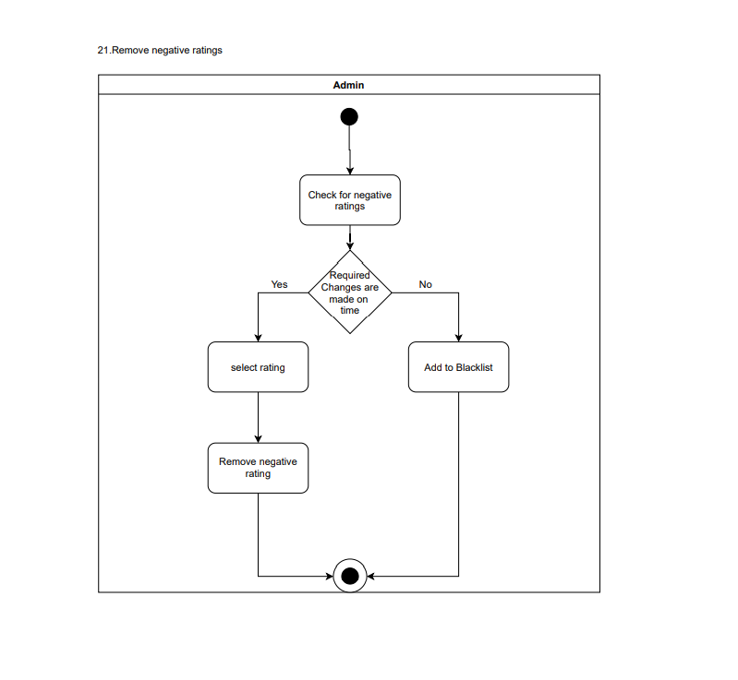

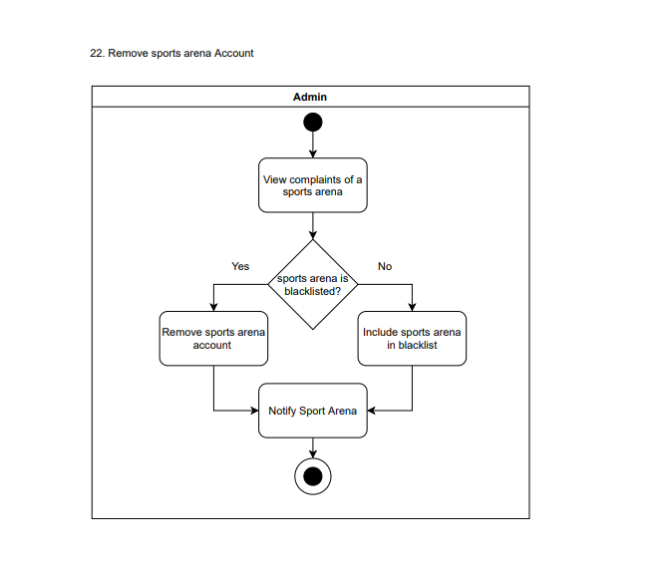

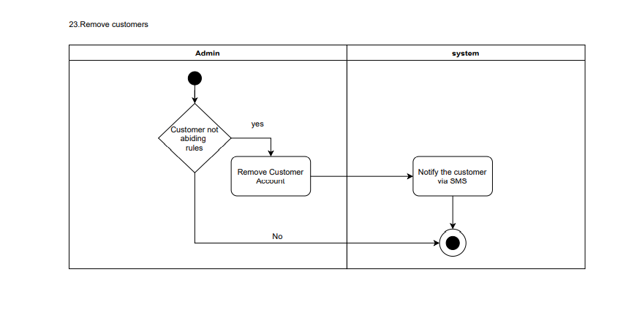

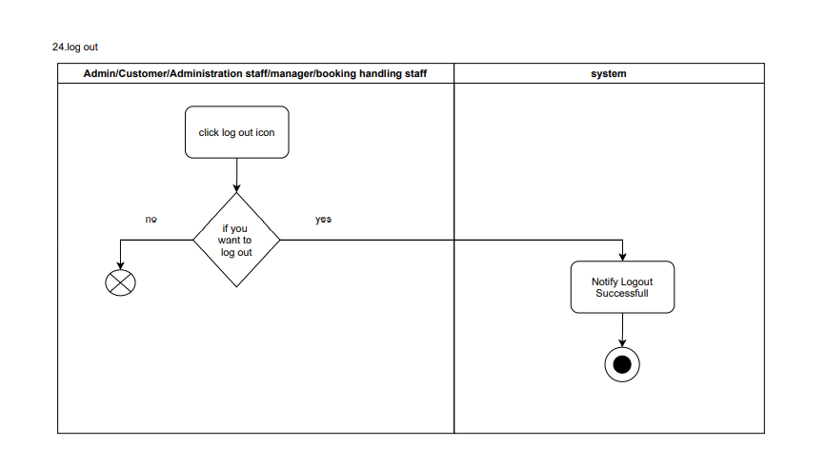

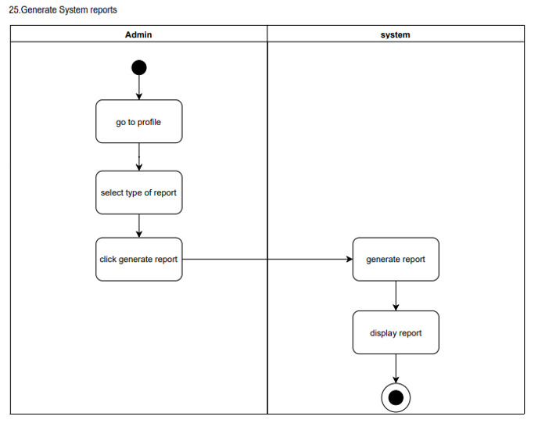

### 9.4 State Transition Diagrams

### 9User Interfaces

#### 10.1 User-Interface Flow Diagrams

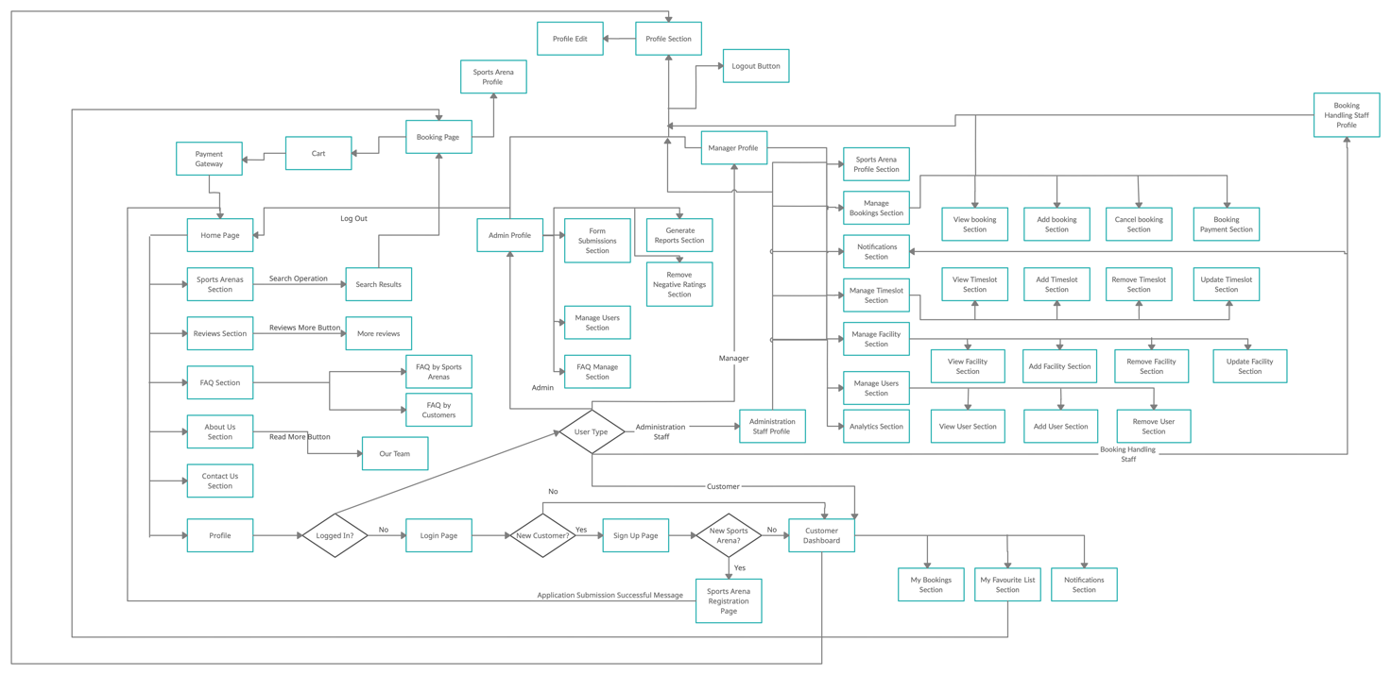

10.2 User Interfaces (Wireframes).

10.2.1 Common Interfaces.

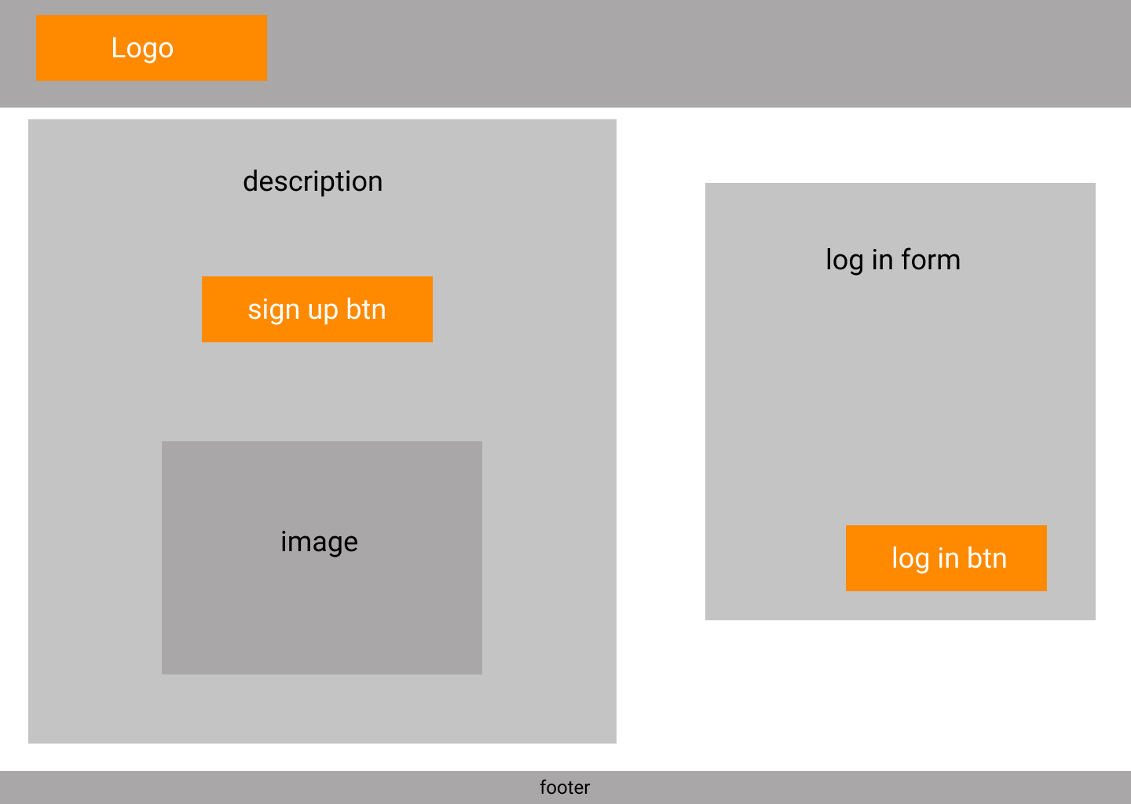

Figure 1:Login Interface

Actors Using the Interface: Customer, Manager, Administration Staff, Booking Handling Staff & Admin.

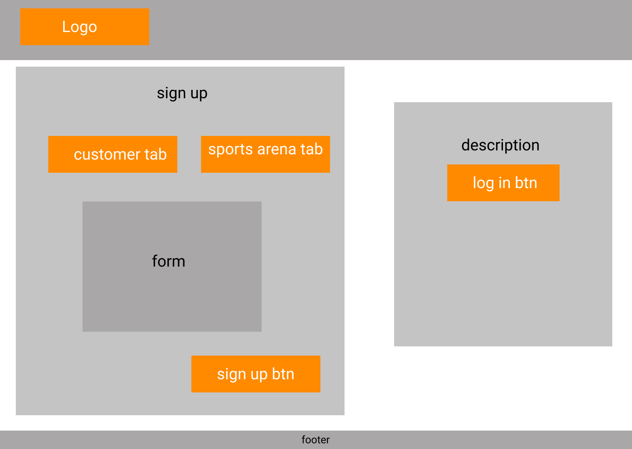

Figure 2:Signup Page

Actors Using the Interface: Customer & Manager.

*Notes: Both the customer tab and sports arena tab has forms. Sports Arena tab has a form for manager account and a separate link for sports arena application submission.*

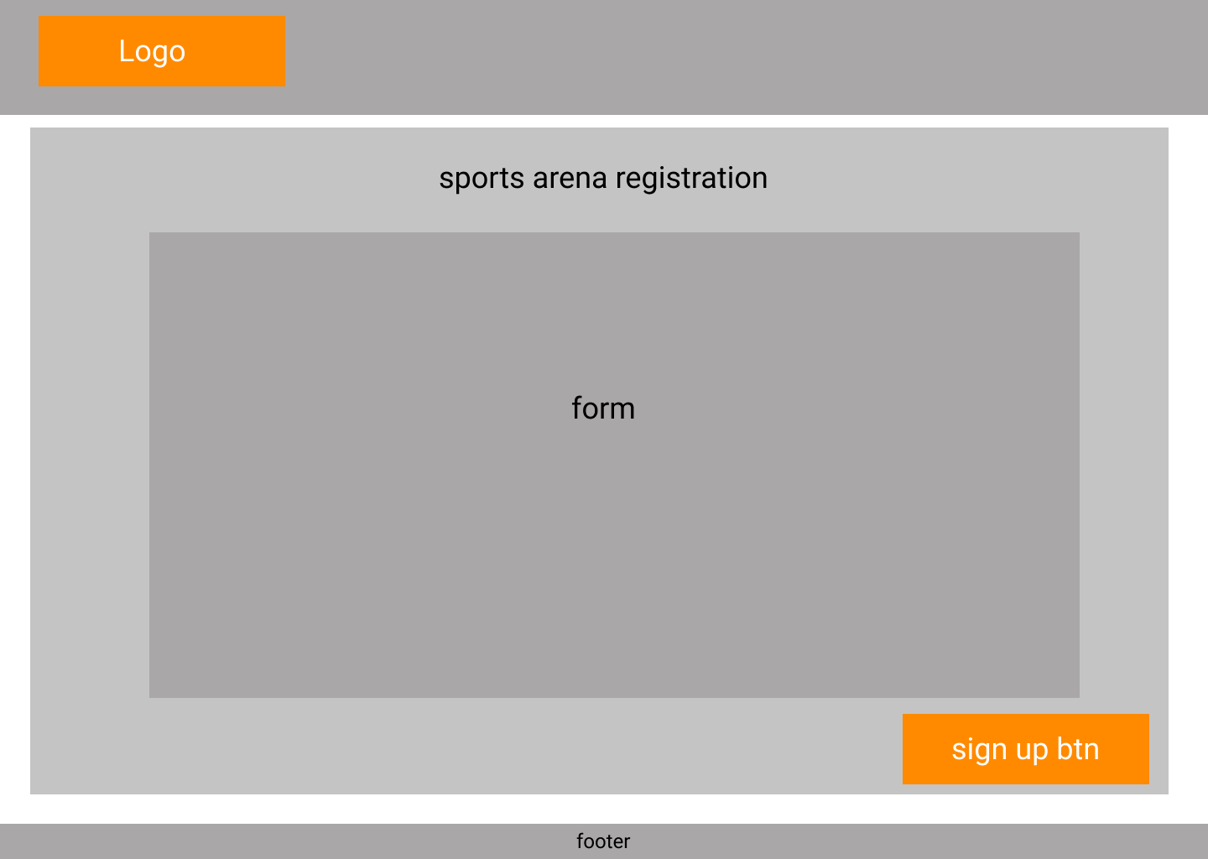

Figure 3:Sports Arena Application

Actor Using the Interface: Manager.

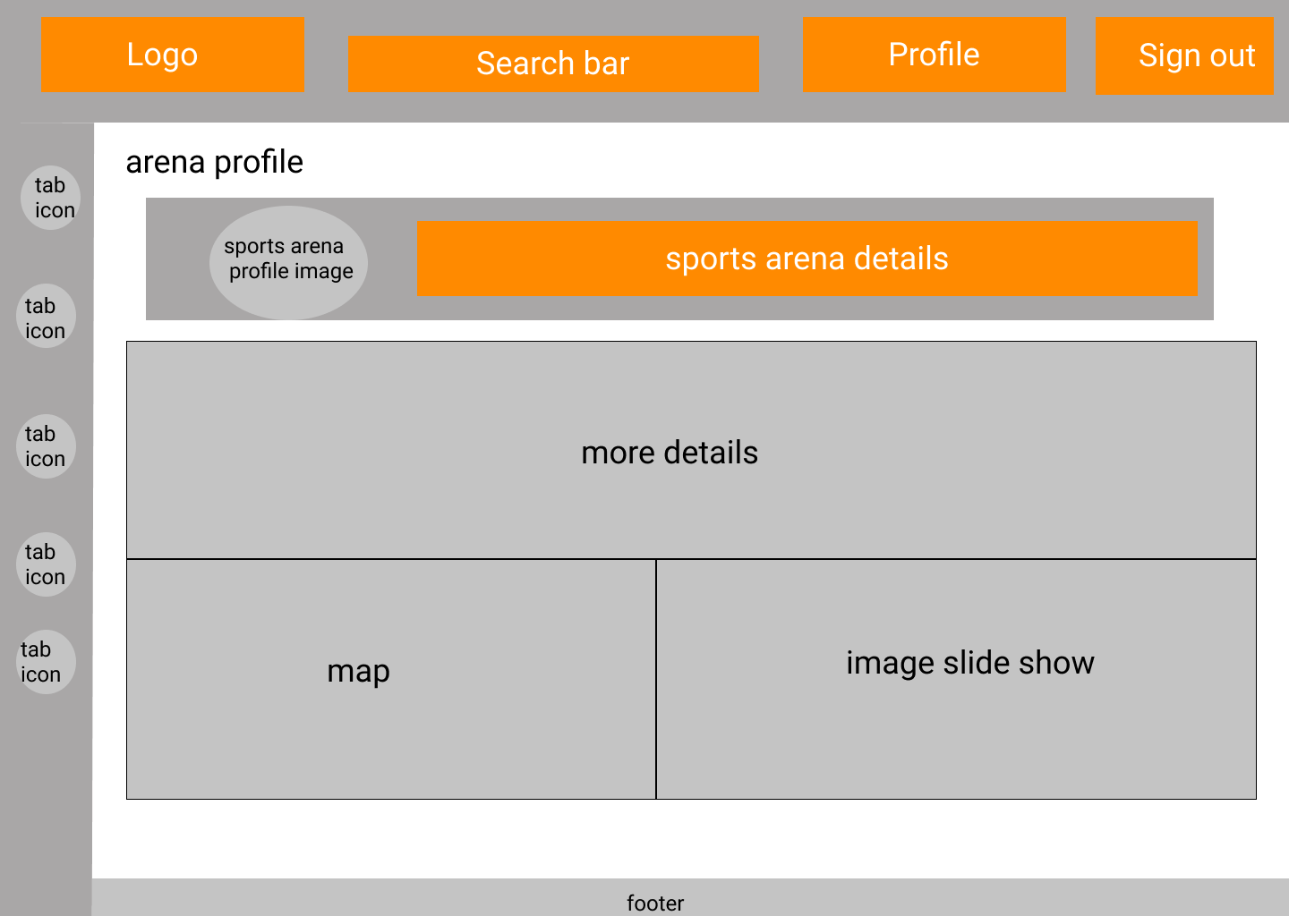

Figure 4:Sports Arena Profile

Actors Using the Interface: Visitor, Customer, Manager, Administration Staff & Booking Handling Staff.

*Notes: Only the Manager & Administration Staff have permission to edit the profile, other users have only view permissions.*

10.2.2 Visitor Interfaces.

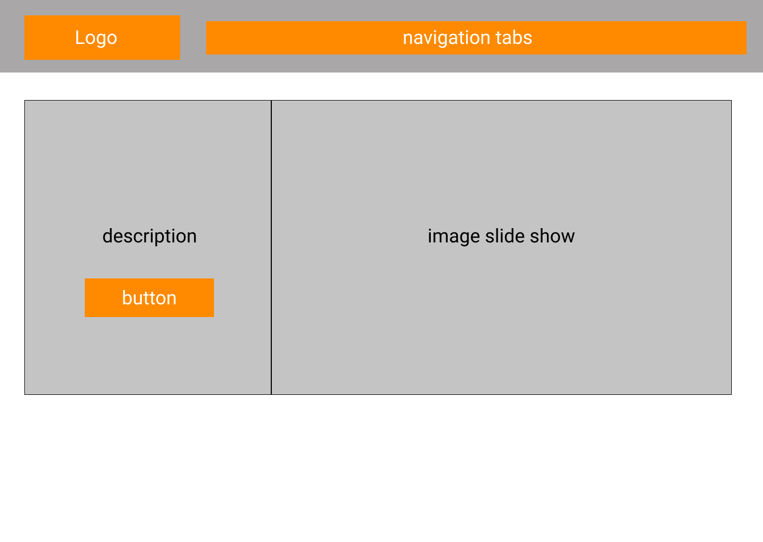

Figure 5:Home section of the Landing Page

Actors Using the Interface: Visitor, Customer, Manager, Administration Staff, Booking Handling Staff & Admin.

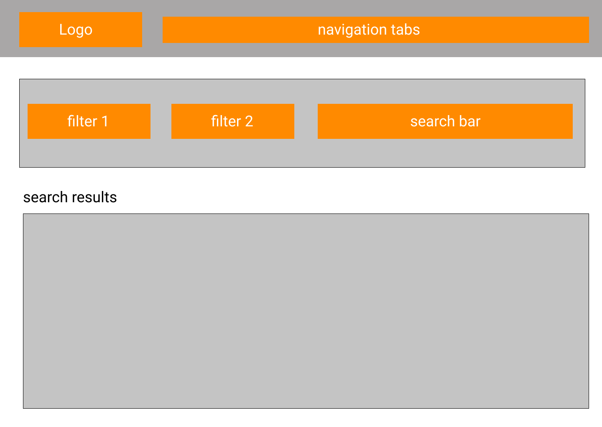

Figure 6: Sports Arena Search Section of Landing Page

Actors Using the Interface: Visitor, Customer, Manager, Administration Staff, Booking Handling Staff & Admin.

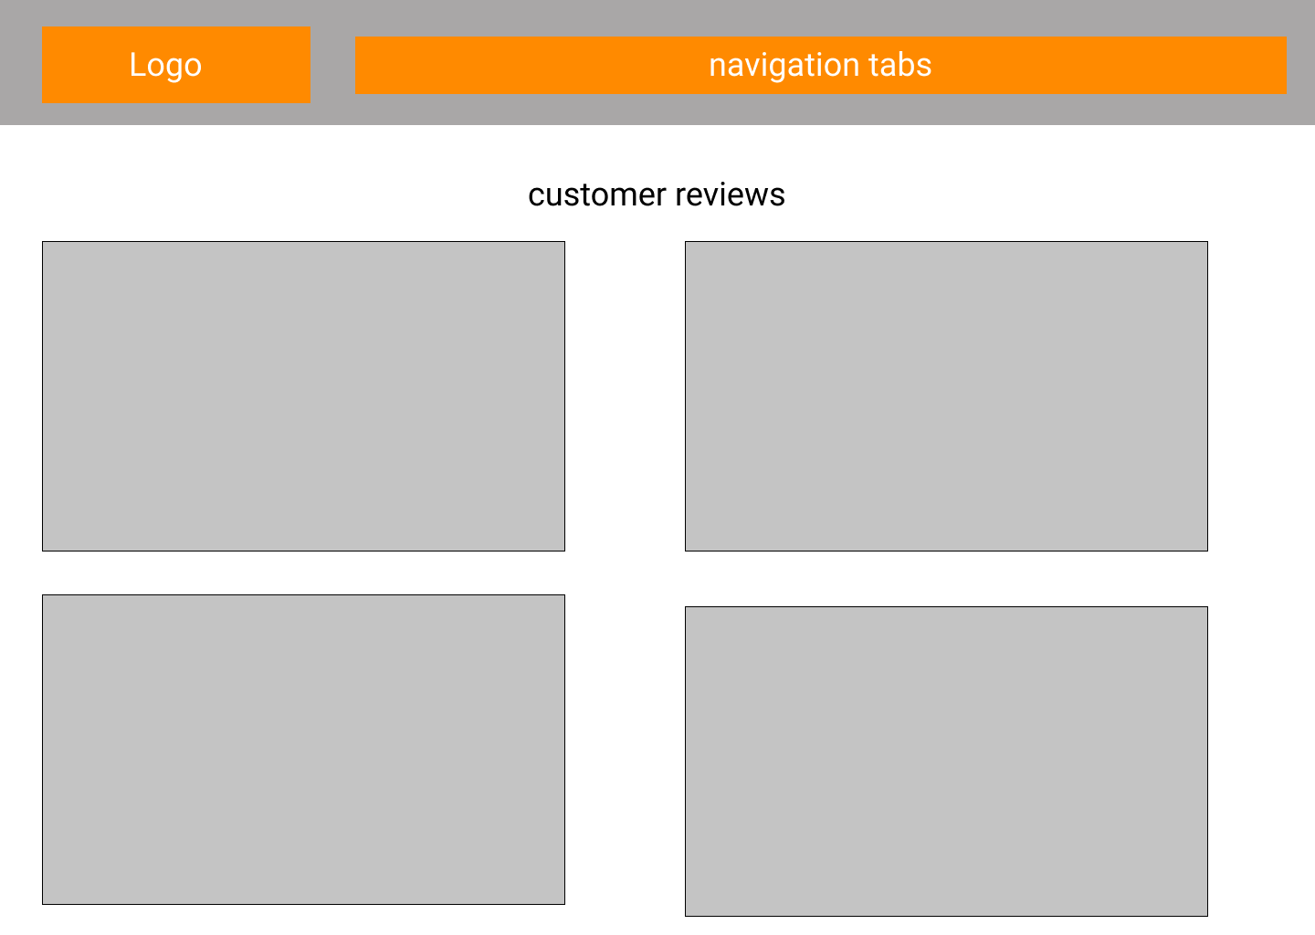

Figure 7: Customer Reviews Section of Landing Page

Actors Using the Interface: Visitor, Customer, Manager, Administration Staff, Booking Handling Staff & Admin.

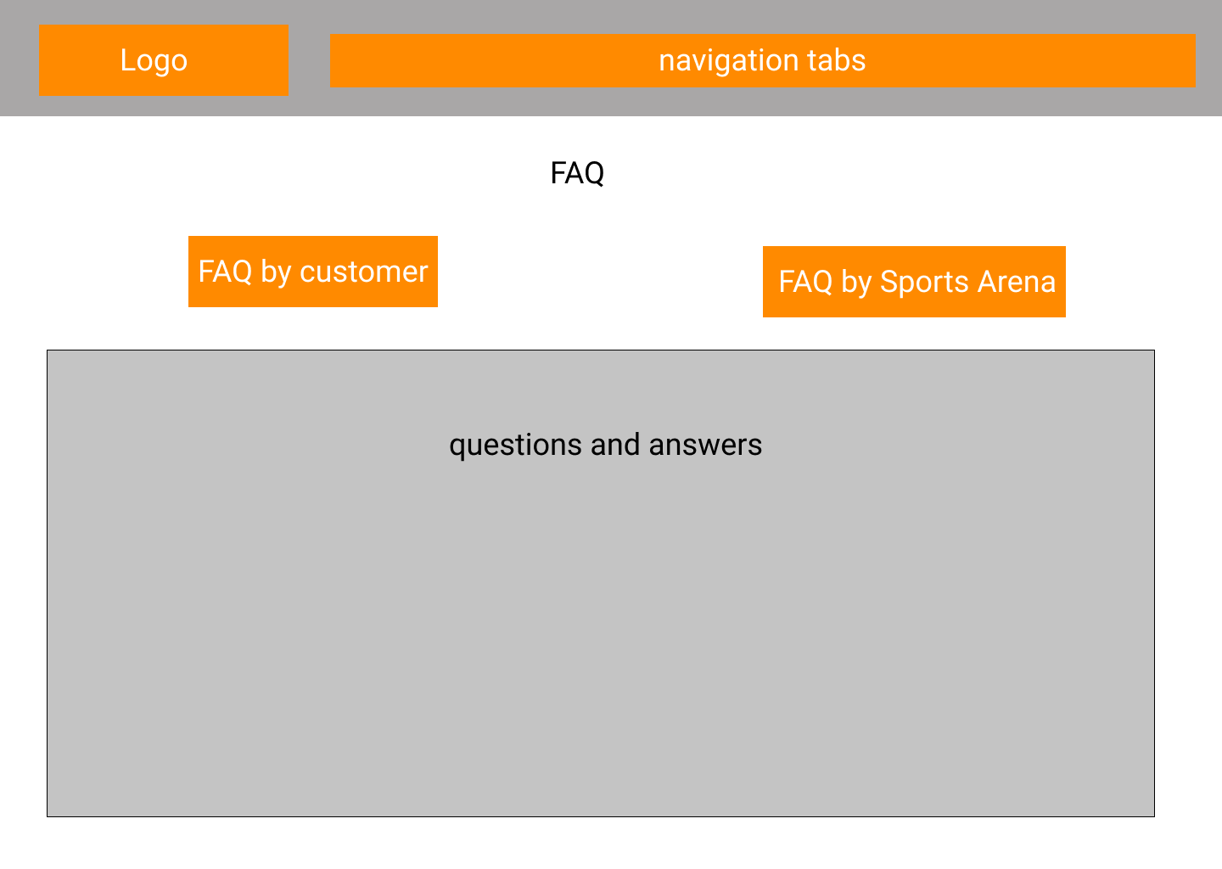

Figure 8:FAQ Section of Landing Page

Actors Using the Interface: Visitor, Customer, Manager, Administration Staff, Booking Handling Staff & Admin.

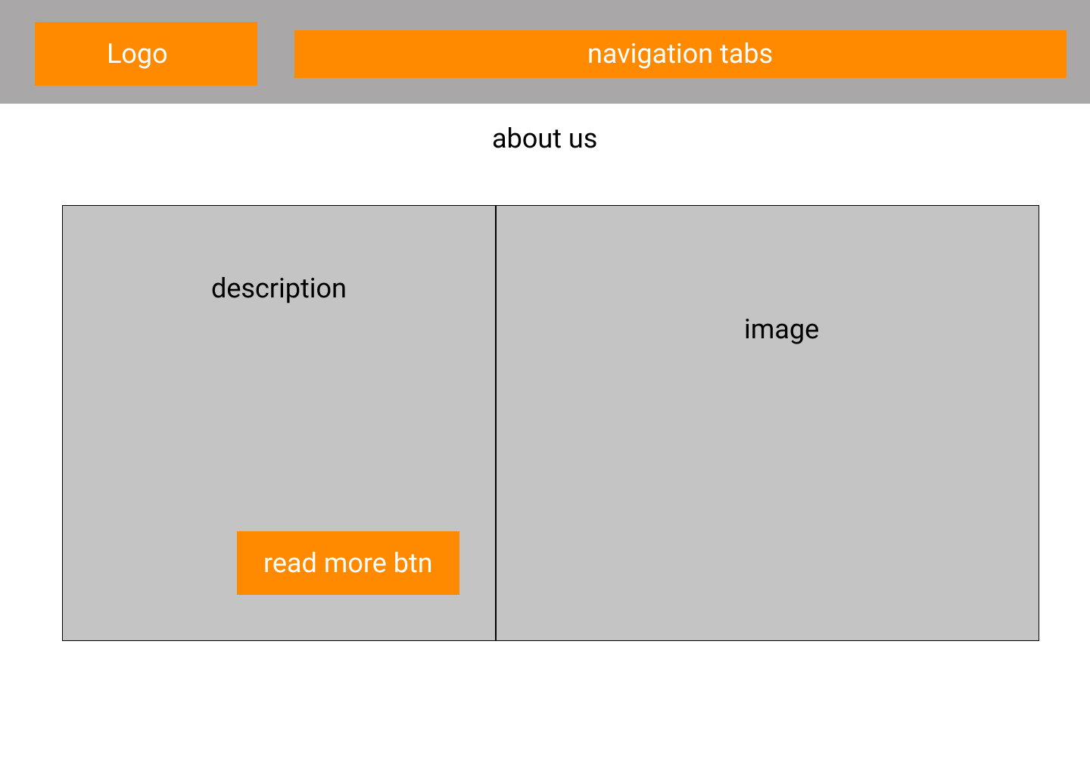

Figure 9: About Us Section of Landing Page

Actors Using the Interface: Visitor, Customer, Manager, Administration Staff, Booking Handling Staff & Admin.

*Note: Read more button will direct to our team section of the landing page.*

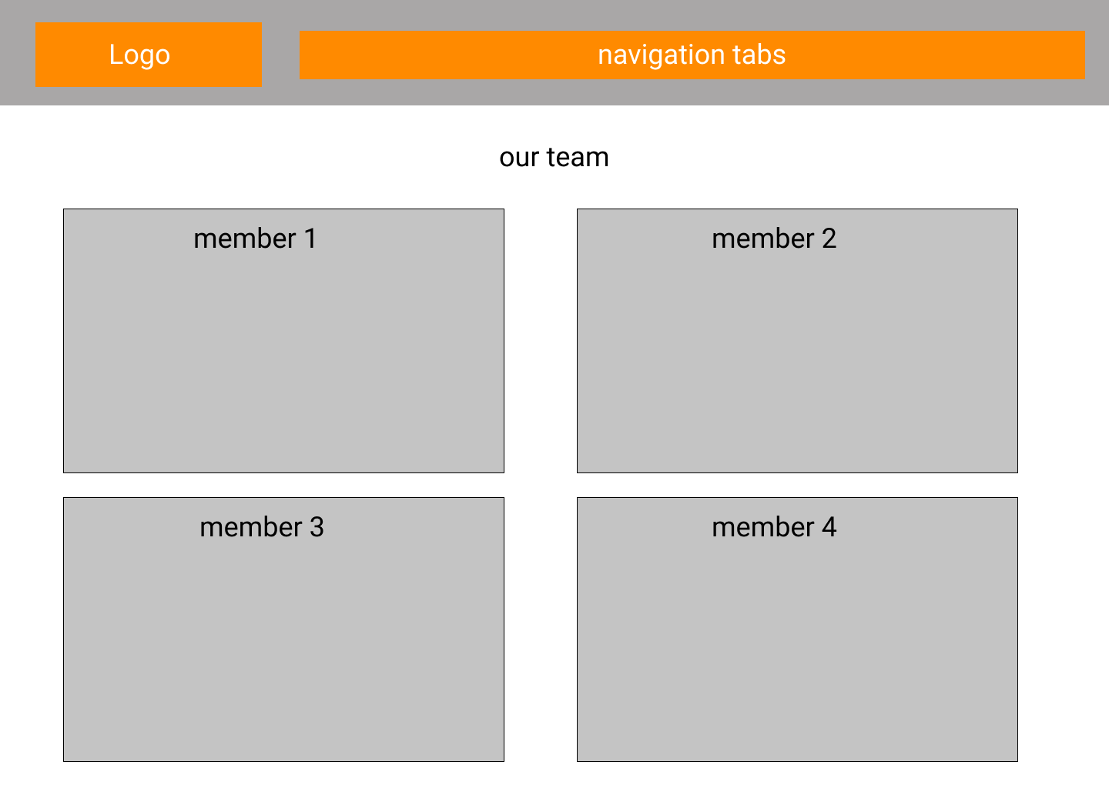

Figure 10: Our Team Section of Landing Page

Actors Using the Interface: Visitor, Customer, Manager, Administration Staff, Booking Handling Staff & Admin.

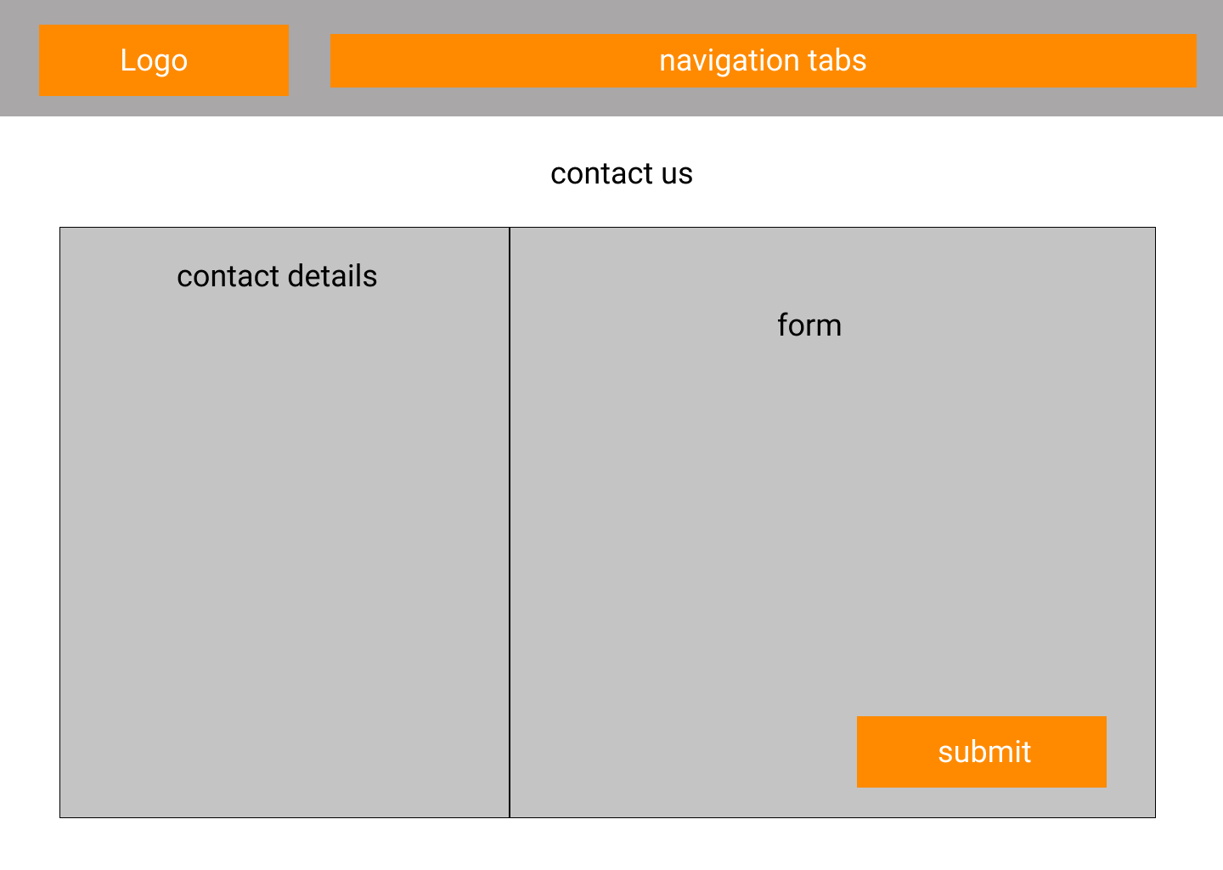

Figure 11: Contact Us Section of Landing Page

Actors Using the Interface: Visitor, Customer, Manager, Administration Staff, Booking Handling Staff & Admin.

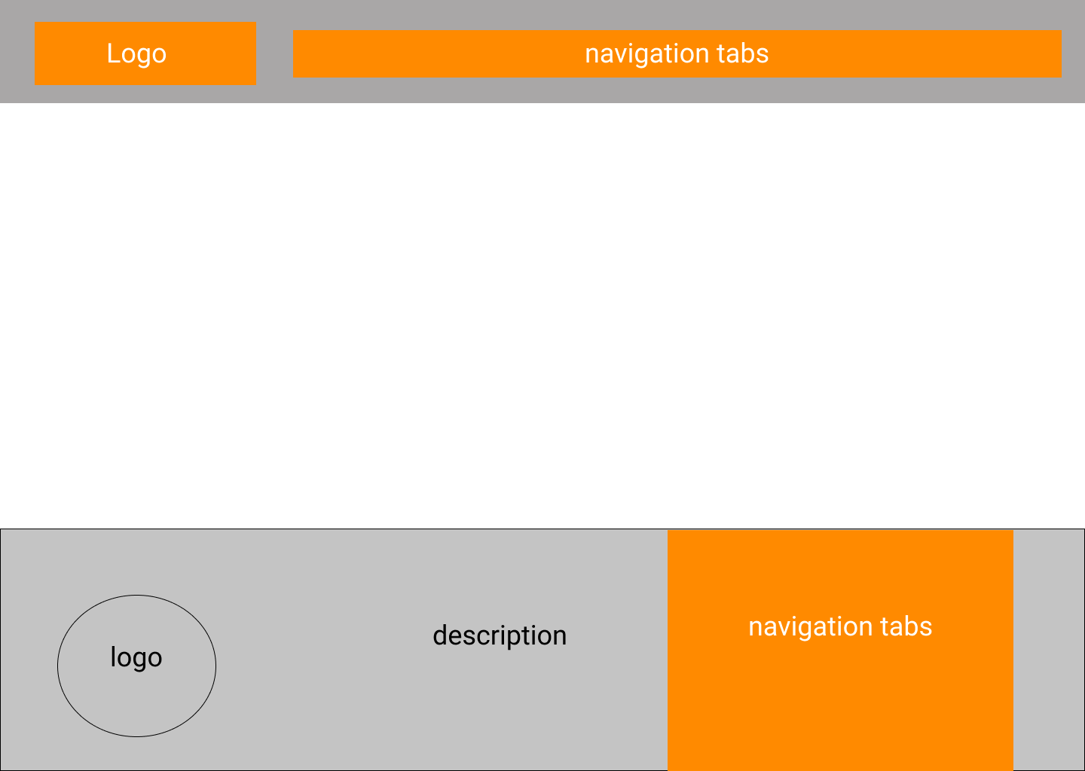

Figure 12:Footer Section of the Landing Page

Actors Using the Interface: Visitor, Customer, Manager, Administration Staff, Booking Handling Staff & Admin.

10.2.3 Customer Interfaces.

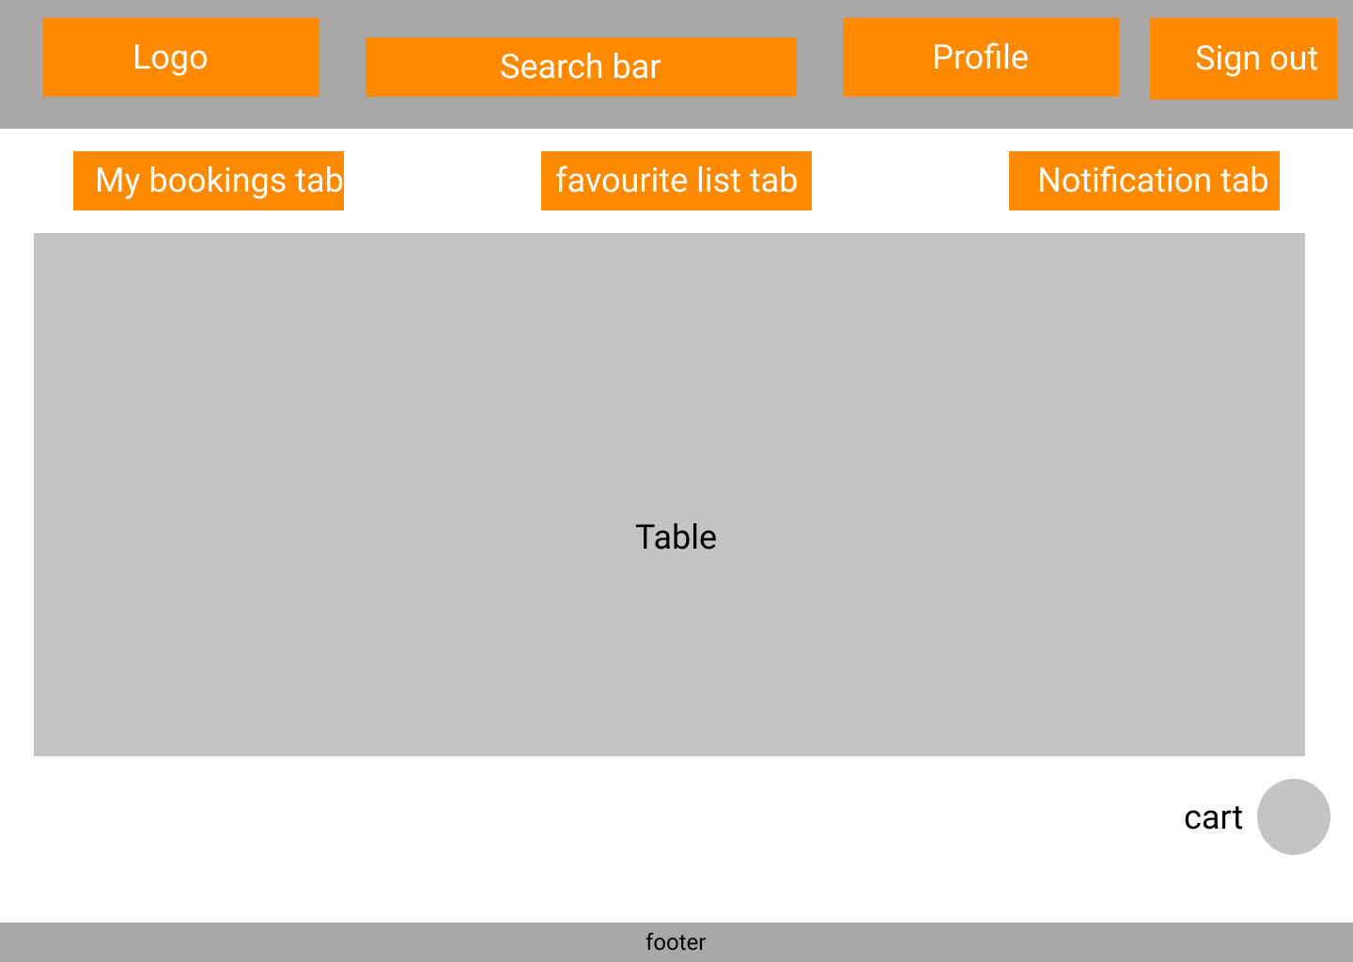

Figure 13:Customer Dashboard

Actor Using the Interface: Customer.

*Note: All 3 tabs consists of tables.*

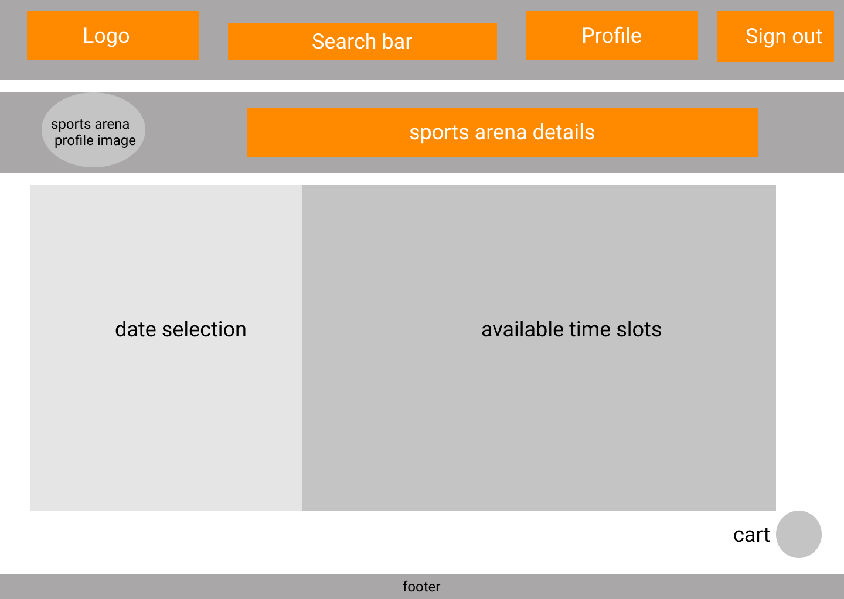

Figure 14:Sports Arena Booking Page

Actor Using the Interface: Customer.

*Note: Customer would arrive at this page by either clicking Availability button from their favorite sports arena list or by clicking the Availability button from the search results at landing page’s sports arena section.*

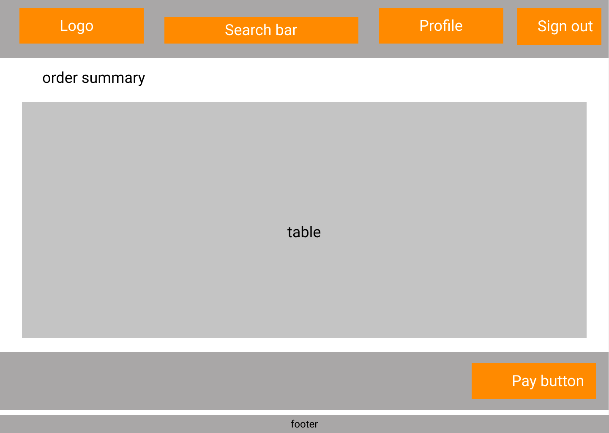

Figure 15:Checkout Page

Actor Using the Interface: Customer.

*Note: User gets directed to the Payment Gateway after clicking the Pay button, if it’s a card transaction.*

10.2.4 Sports Arena Staff Interfaces.

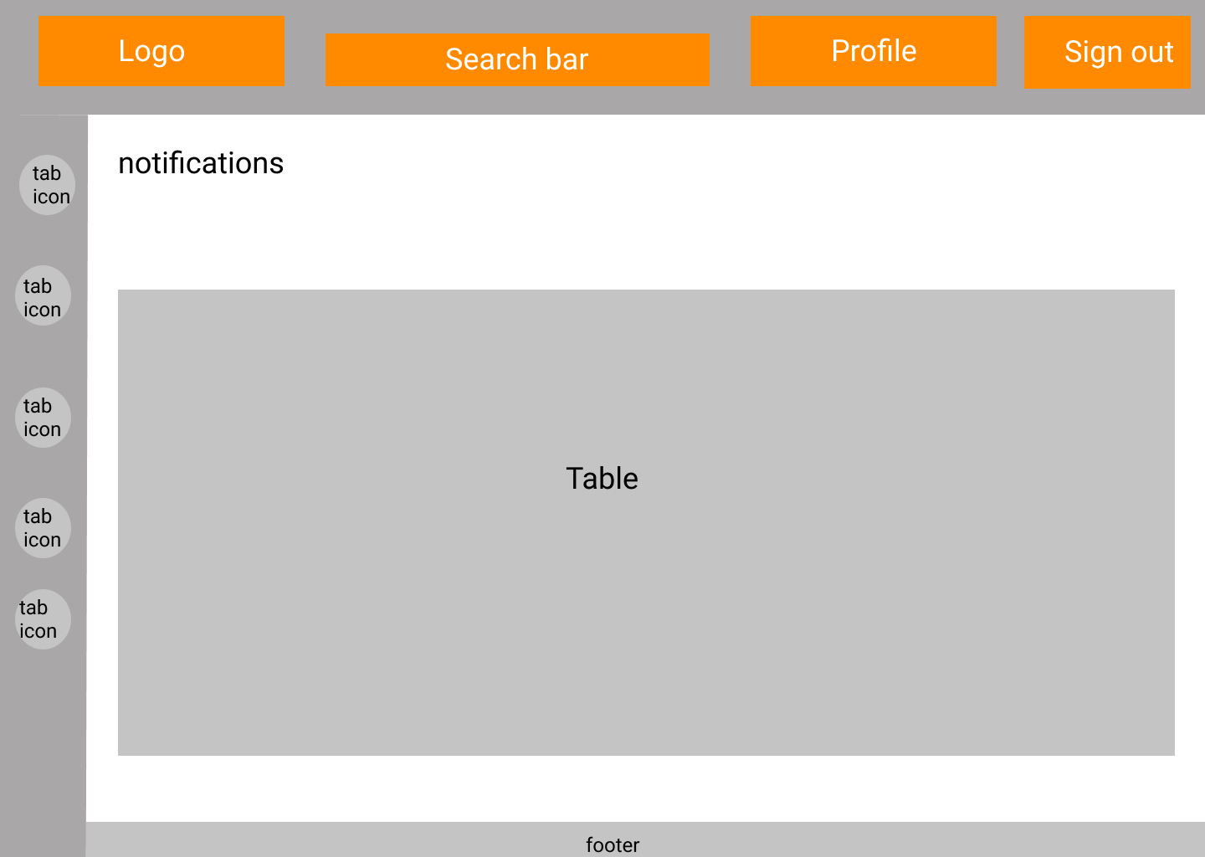

Figure 16:Notifications Page

Actors Using the Interface: Manager, Administration Staff & Booking Handling Staff

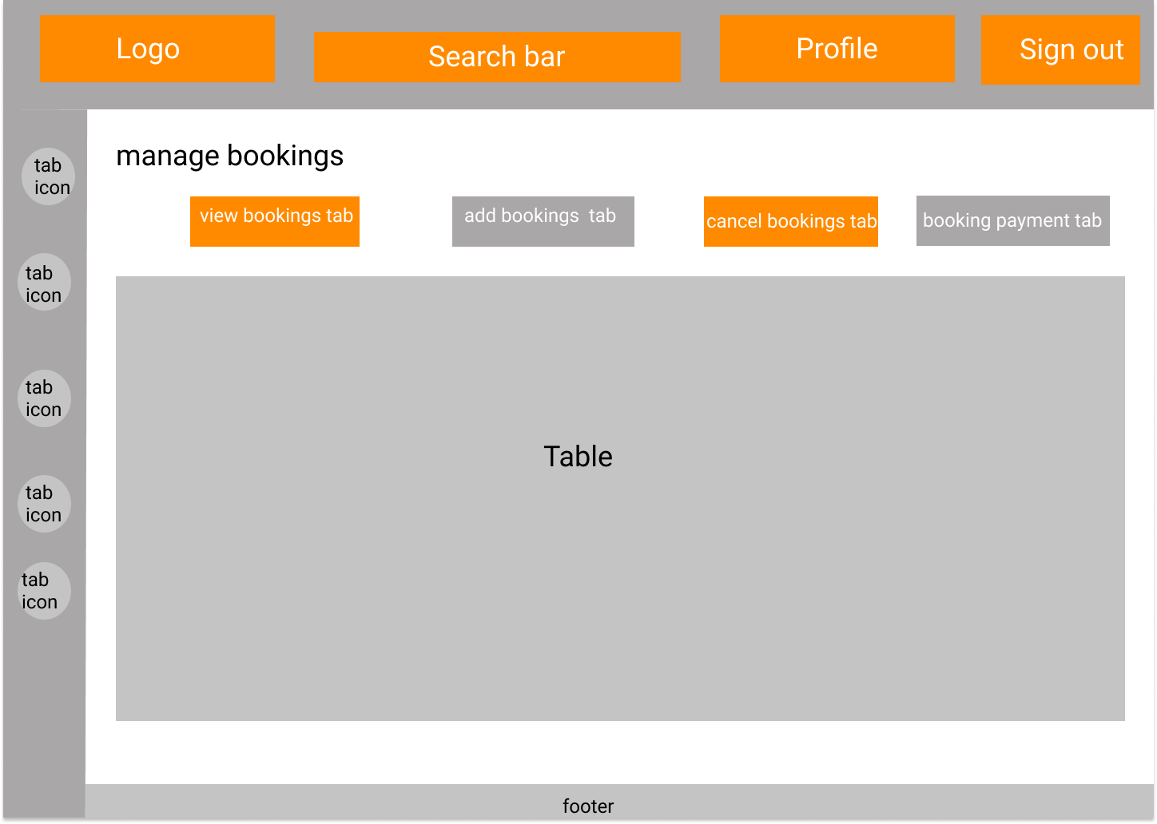

Figure 17:Manage Bookings Page (View bookings tab & Cancel Bookings tab)

Actors Using the Interface: Manager & Administration Staff

*Note: Both the View bookings tab and cancel bookings tab consists of tables.*

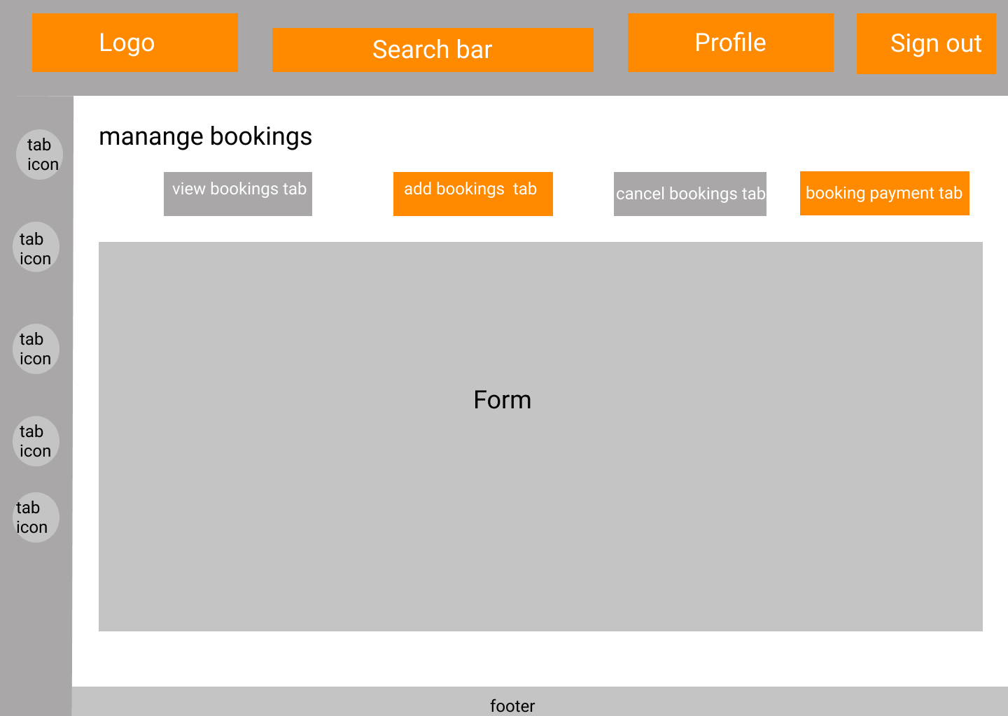

Figure 18:Manage Bookings Page (Add bookings tab & Booking Payment tab)

Actors Using the Interface: Manager & Administration Staff

*Note: Both the Add bookings tab and booking payment tab consists of forms.*

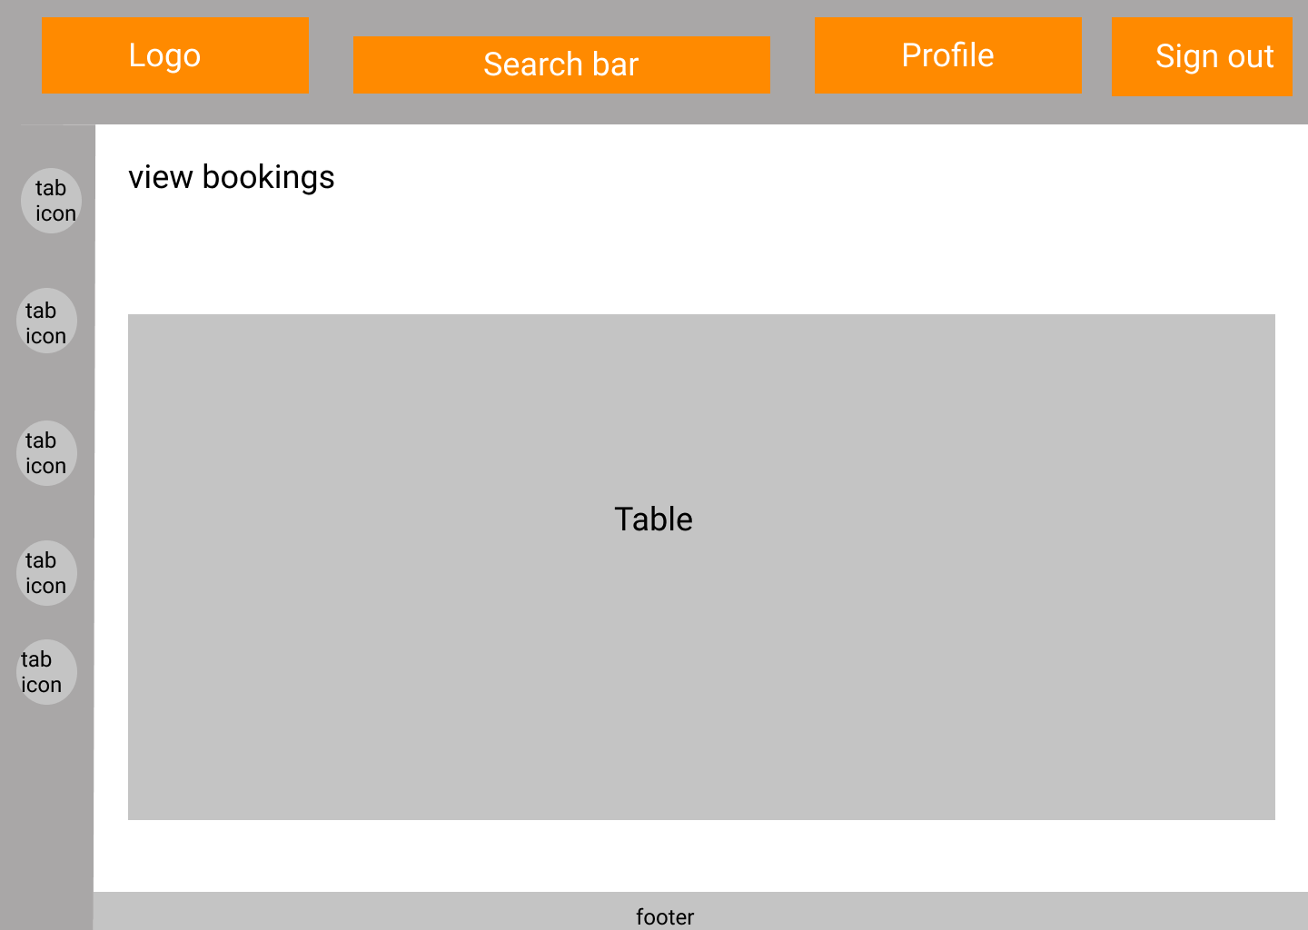

Figure 19:View Bookings Page

Actors Using the Interface: Booking Handling Staff

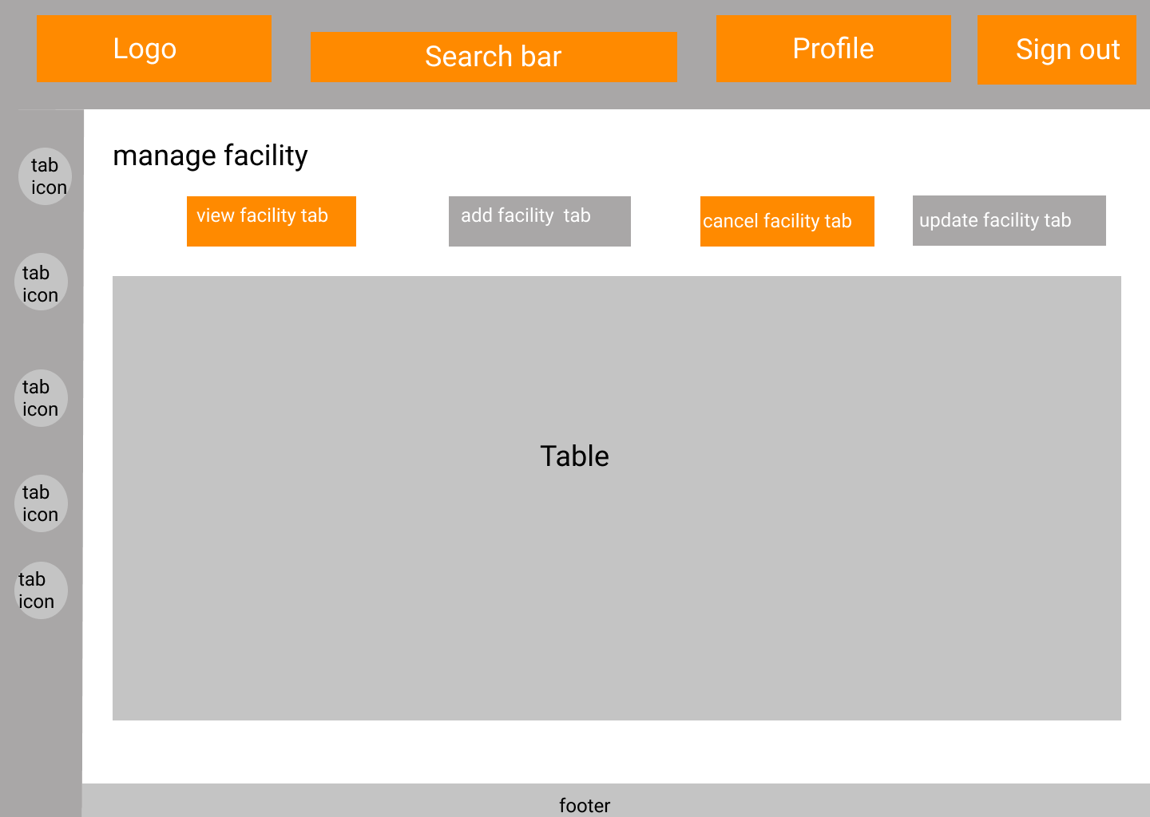

Figure 20:Manage Facility Page (View Facility Tab & Remove Facility Tab)

Actors Using the Interface: Manager & Administration Staff

*Note: Both the View facility tab and cancel facility tab consists of tables.*

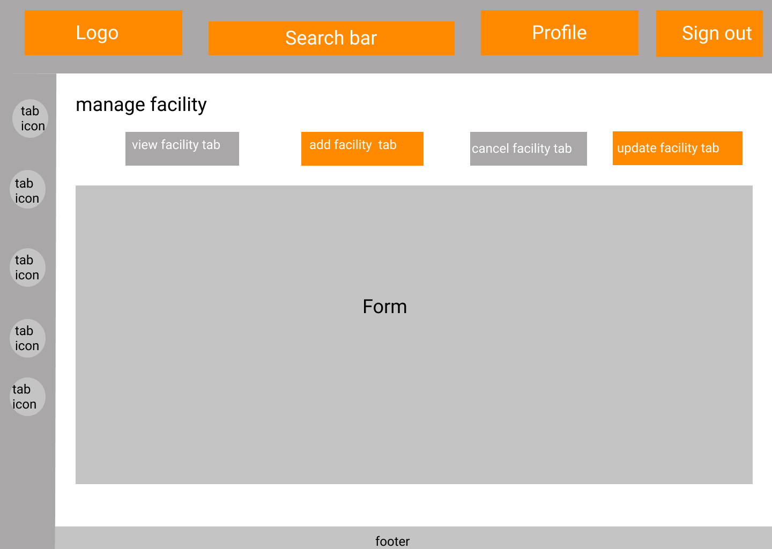

Figure 21: Manage Facility Page (Add Facility Tab & Update Facility Tab)

Actors Using the Interface: Manager & Administration Staff

*Note: Both the Add facility tab and update facility tab consists of forms.*

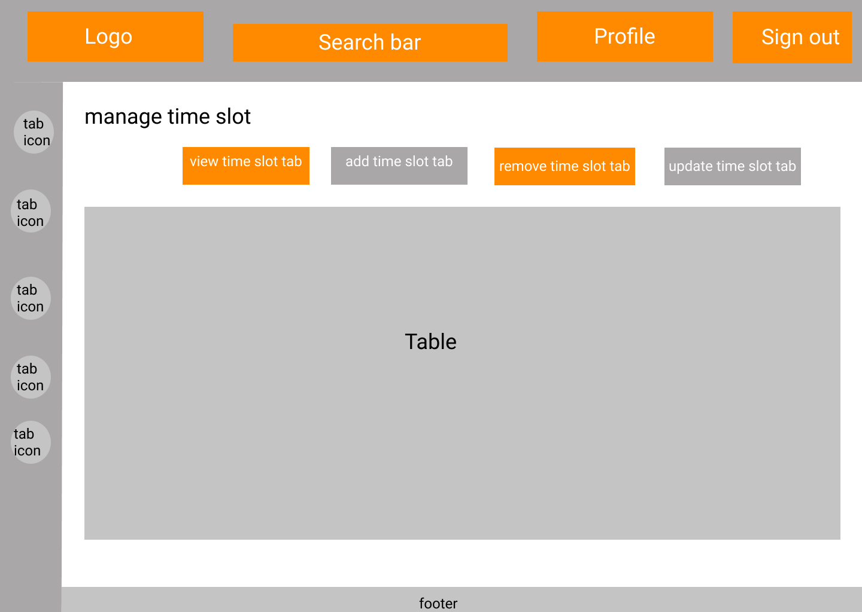

Figure 22:Manage Time Slot (View Time slot tab & Cancel Time slot tab)

Actors Using the Interface: Manager & Administration Staff

*Note: Both the View Time slot tab and cancel time slot tab consists of tables.*

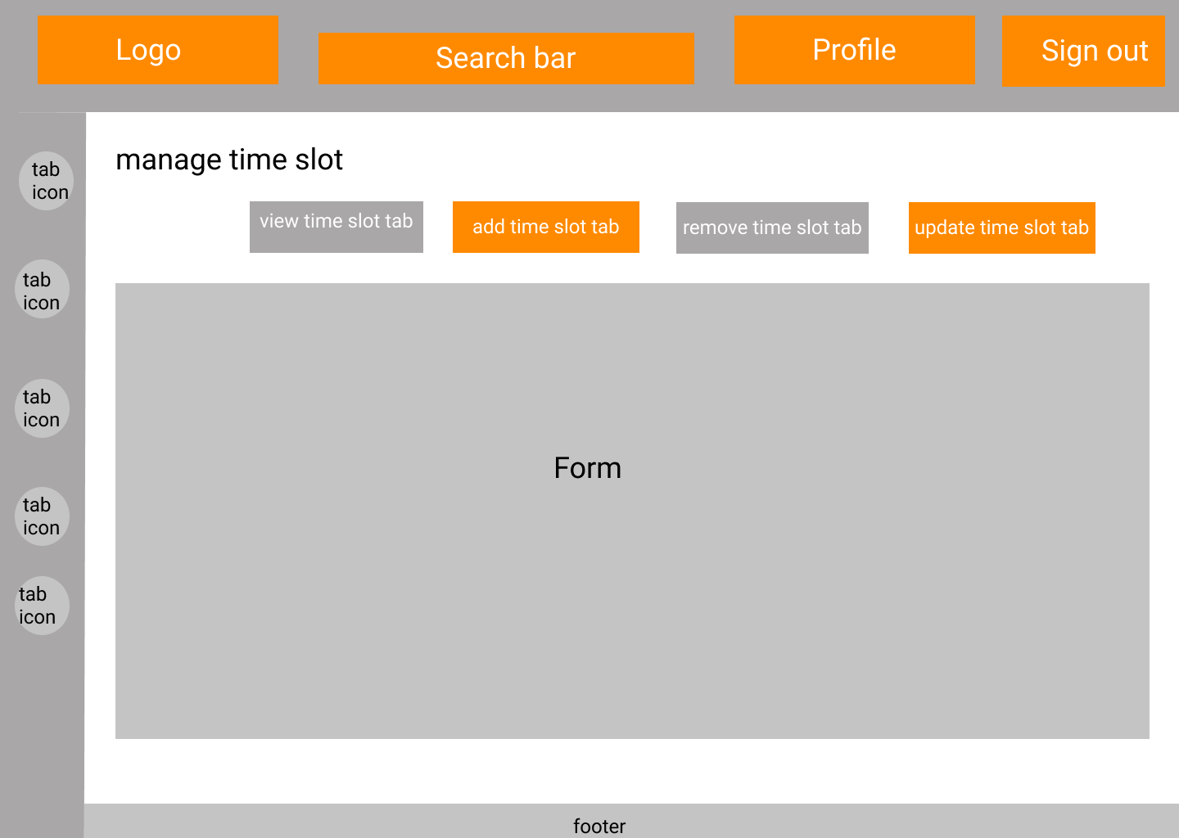

Figure 23:Manage Time Slot (Add Time slot tab & Update Time slot tab)

Actors Using the Interface: Manager & Administration Staff

Note: Both the View Time slot tab and cancel time slot tab consists of forms.

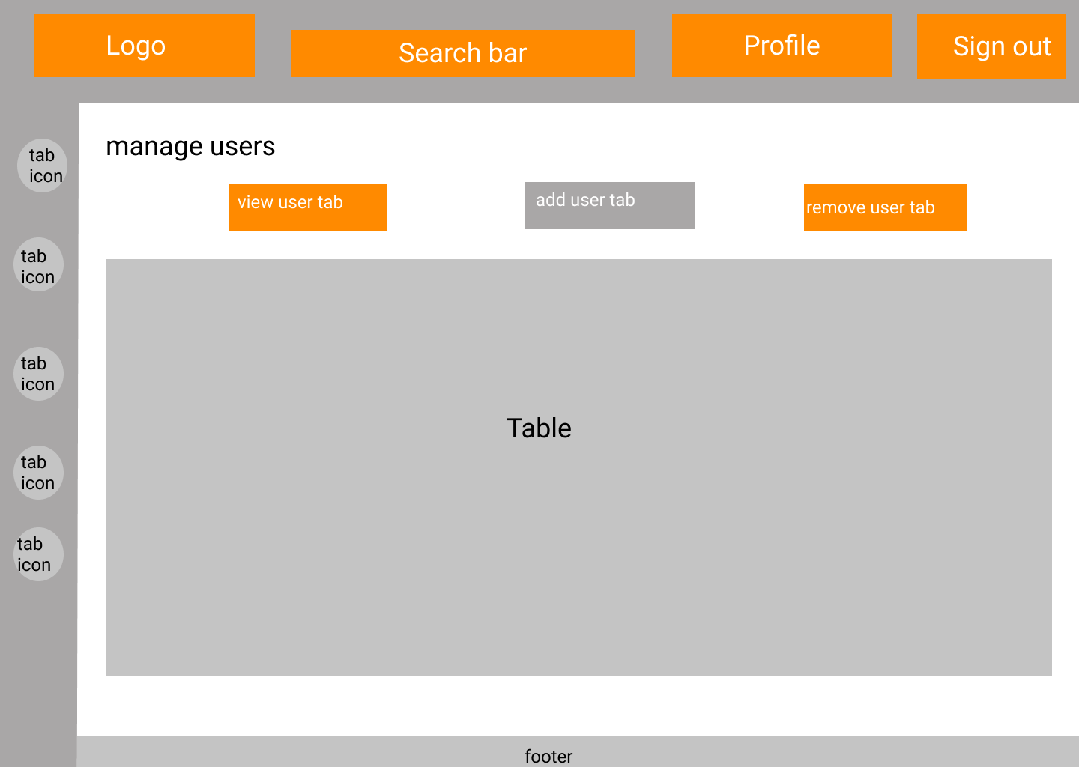

Figure 24:Manage User Page (View Users tab & Remove Users tab)

Actor Using the Interface: Manager

*Note: Both the View User tab and remove user tab consists of tables.*

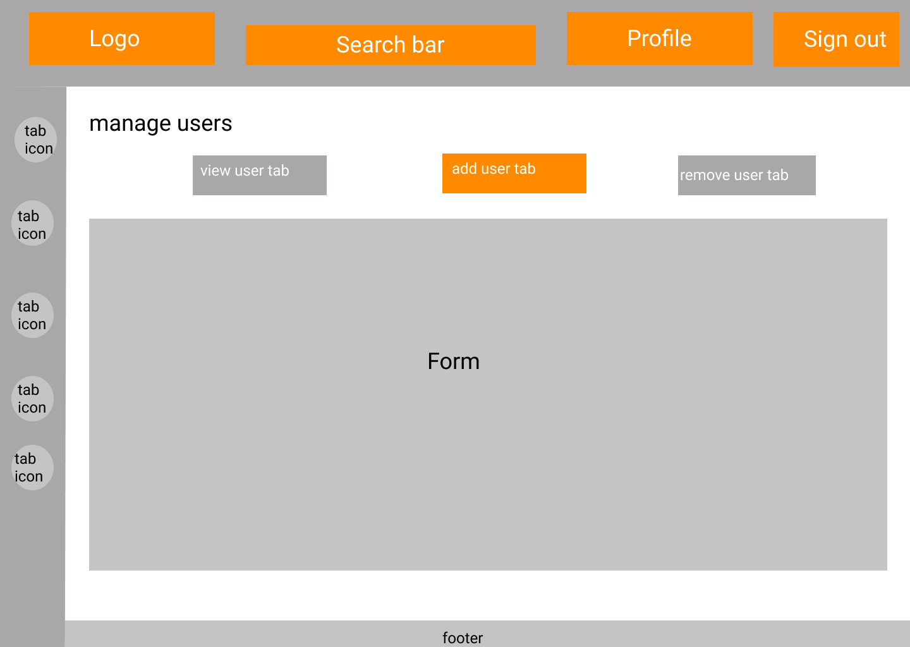

Figure 25:Manage Users Page (Add Users tab)

Actor Using the Interface: Manager

*Note: Add user tab consists of a form*

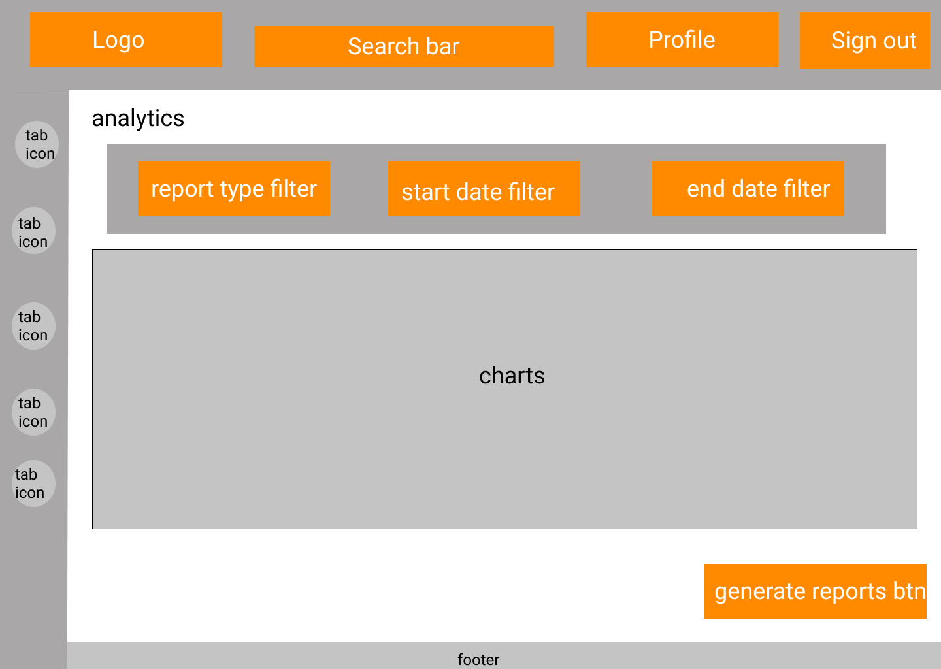

Figure 26:Analytics Page for Sports Arena

Actor Using the Interface: Manager

10.2.7 Admin Interfaces.

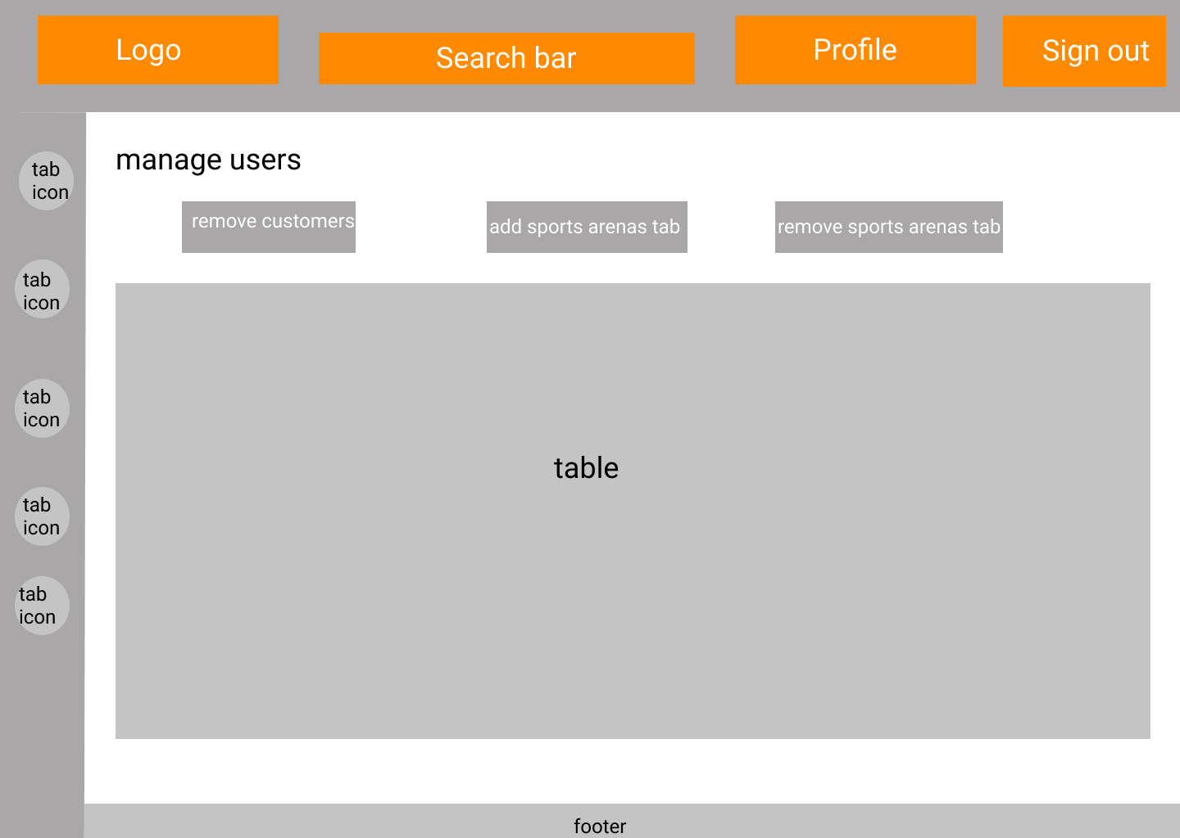

Figure 27: Manage Users Page for Admin

Actor Using the Interface: Admin

**

Figure 28: System Analytics Page

Actor Using the Interface: Actor

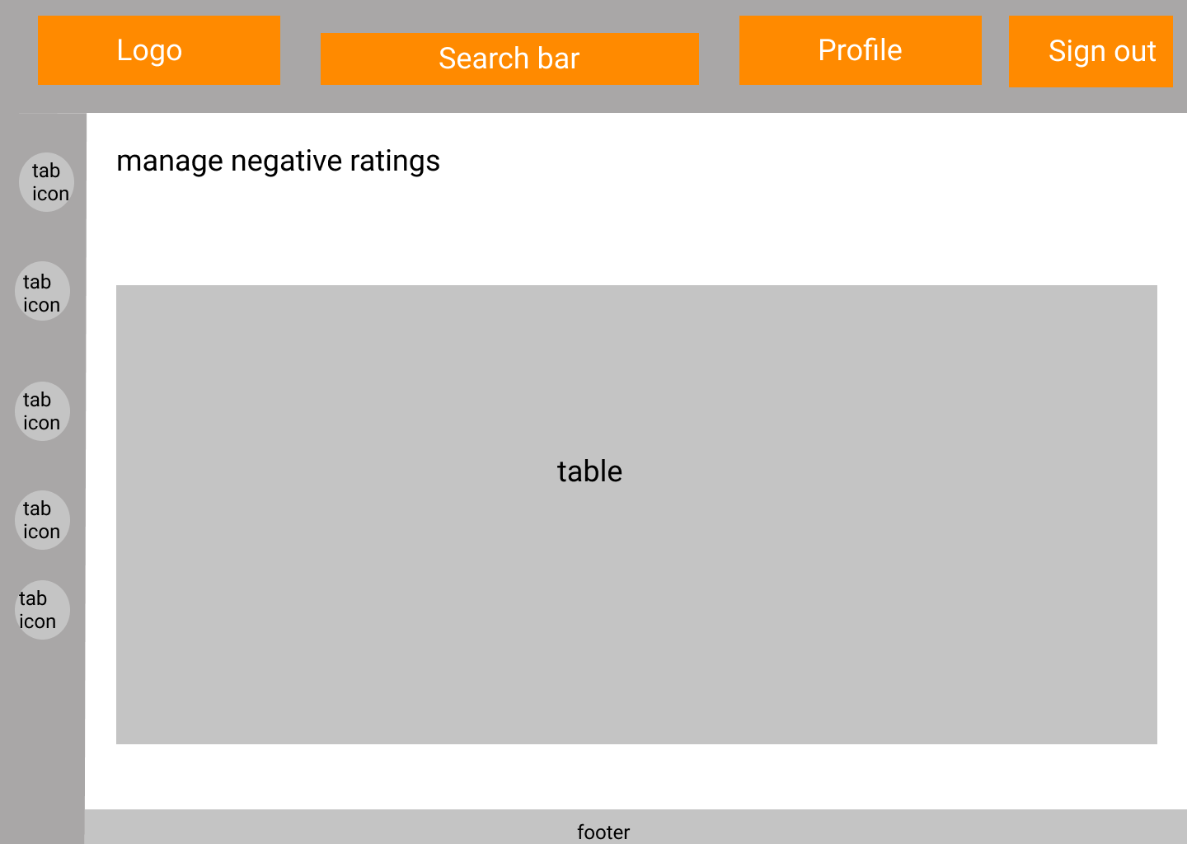

Figure 29:Manage Negative Ratings Page

Actor Using the Interface: Actor

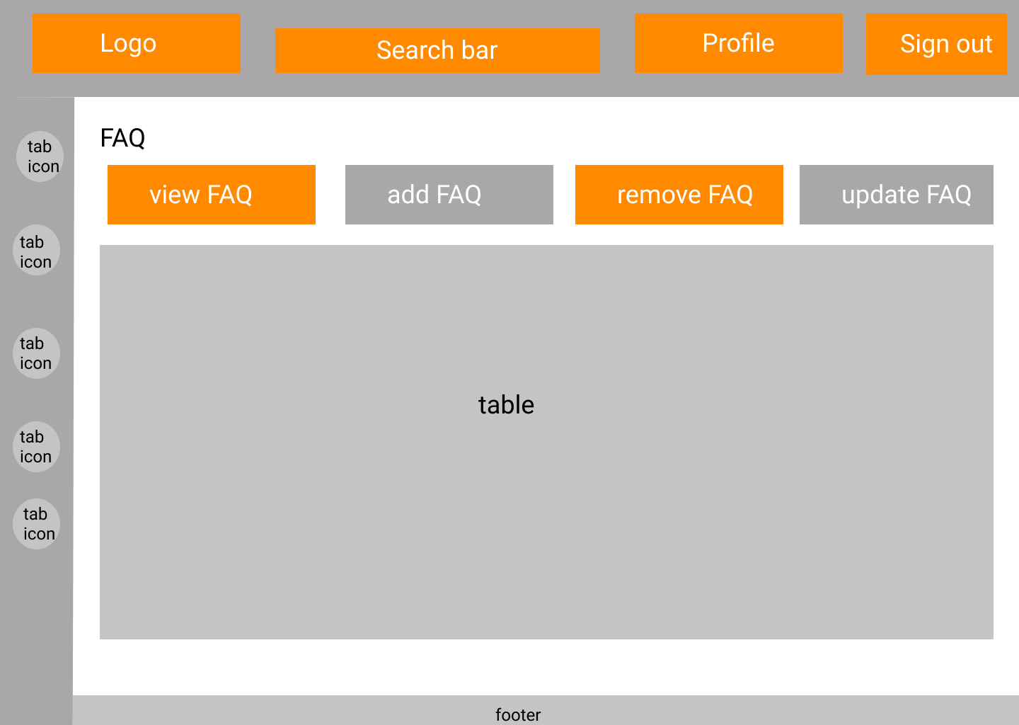

Figure 30:Manage FAQ Page (View FAQ tab & Remove FAQ tab)

Actor Using the Interface: Actor

*Note: Both the View FAQ tab and remove FAQ tab consists of tables.*

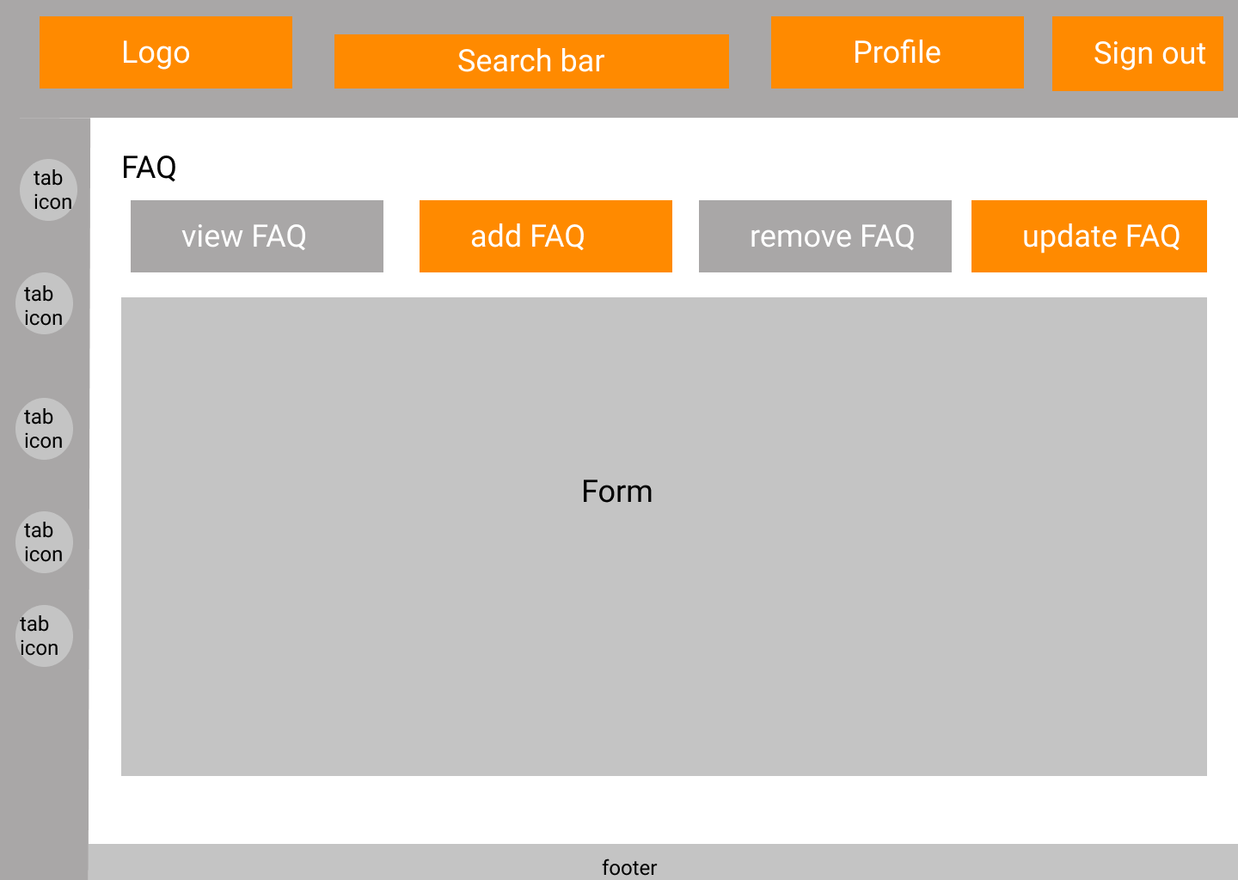

Figure 31:Manage FAQs (Add FAQ tab & Update FAQ tab)

Actor Using the Interface: Actor

*Note: Both the Add FAQ tab and Update FAQ tab consists of forms*

# Deliverables of the project

* Progressive Web Application (PWA).

Progressive Web Application, where users can create their accounts and log in to the system. All the roles in the system can interact with the system through the web application.

* User manuals for the sports arenas with screenshots attached.

Containing all the instructions, the user manual shall be provided to all the sports arenas that are getting listed themselves on our platform.

* Software Requirement Specification (SRS).

Including the problem background, objectives to be achieved upon completion, feasibility study, scope, functionality and quality attribute and design specifications illustrated with various diagrams.

# Declaration

*We as members of the project titled “Sportizza”, Certify that we will carry out this project according to the guidelines provided by the coordinators and supervisors of the course as well as we will not incorporate, without acknowledgement, any material previously submitted for a degree or diploma in any university. To the best of our knowledge and brief, the project work will not contain any material previously published or written by another person or ourselves except where due reference is made in the text of appropriate places.*

|  |  |  |
| --- | --- | --- |
| 19001942 | W. L. P. MANETH WIJETUNGA |  |
| 19000286 | J. P. M. DASS |  |
| 19001312 | H.B.S. BHASHITHA RANASINGHE | Picture 9 |
| 19000782 | K. P. D. PRASAD LAKSHAN |  |